

EDUA PROJECT REPORT
Report 3 – Software Requirement Specification

– Hanoi, Jun 2026 –
Table of Contents
I. Record of Changes 3
II. Software Requirement Specification 4
1. Overall Requirements 4
1.1 Context Diagram 4
1.2 Main Workflows 5
1.3 User Requirements 9
1.4 System Functionalities 19
1.5 Entity Relationship Diagram 23
2. Use Case Specifications 27
2.1 Lesson 27
2.2 Test 30
2.3 Slide 33
2.4 Common 36
3. Functional Requirements 37
3.1 Lesson 37
3.2 Slide 42
3.3 Test 51
3.4 Landing Page 56
4. Non-Functional Requirements 57
4.1 External Interfaces 57
4.2 Quality Attributes 58
5. Requirement Appendix 60
5.1 Business Rules 60
5.2 System Messages 61
5.3 Research References 62

I. Record of Changes
Date | A*  M, D | In charge | Change Description
07/06/2026 | A | Bách | Created document structure and Table of Contents for Report 3 - Software Requirement Specification
08/06/2026 | A | Bách | Added section 1. Overall Requirements (Context Diagram, Main Workflows)
10/06/2026 | A | Bách | Added 1.3 User Requirements and 1.4 System Functionalities
12/06/2026 | A | Bách | Added 1.5 Entity Relationship Diagram
14/06/2026 | A | Bách | Added section 2. Use Case Specifications (Lesson, Test, Slide, Common)
16/06/2026 | A | Bách | Added section 3. Functional Requirements (Lesson, Slide, Test, Landing Page)
18/06/2026 | A | Bách | Added section 4. Non-Functional Requirements (External Interfaces, Quality Attributes)
19/06/2026 | A | Bách | Added section 5. Requirement Appendix (Business Rules, System Messages, Research References)
20/06/2026 | M | Bách | Reviewed and updated content based on feedback comments
*A - Added M - Modified D - Deleted

II. Software Requirement Specification

1. Overall Requirements

1.1 Context Diagram
EDUA is a web-based, AI-assisted platform built for the STEM teachers of THPT Lê Quý Đôn Hà Đông, supporting Chemistry, Physics, and Mathematics for grades 10–12 in alignment with the "Kết nối tri thức" (KNTT) textbook series — the set the school will adopt in the coming school year under Vietnam's national general-education curriculum (GDPT 2018). The platform is a teacher-facing tool: teachers author and present content, while students only view the teacher's material projected during class. Developed as a non-commercial academic project, EDUA scoped as a pilot for a single school.
EDUA addresses three recurring pain points for the school's STEM teachers: the time spent preparing lesson plans and slides, the difficulty of visualizing experiments and reaction mechanisms at the microscopic level, and the effort of producing exams from textbook content. Its core is an AI pipeline that generates a lesson plan and then a slide deck from the KNTT knowledge base, with free-prompt AI editing of lessons, slides, and exams. Its differentiating feature is microscopic 3D simulation of atoms, molecules, and reaction mechanisms - most fully developed for Chemistry, with a phenomena hub for Physics and pre-built static visuals for Mathematics - supported by a virtual lab and a teacher resource-sharing hub.
Release 1.0 covers eight functional features - Authentication, Lesson, Slide, Simulation, Test, Personal Library, Community Hub, and Blog - together with a Management capability for moderators and administrators (account management, content moderation, and system administration). It deliberately excludes student and parent accounts, online grading, native mobile apps, school-management functions, and any payment or marketplace capability. The context diagram below illustrates the external entities (system actors and connected services) that interface with EDUA and the data flows between them.
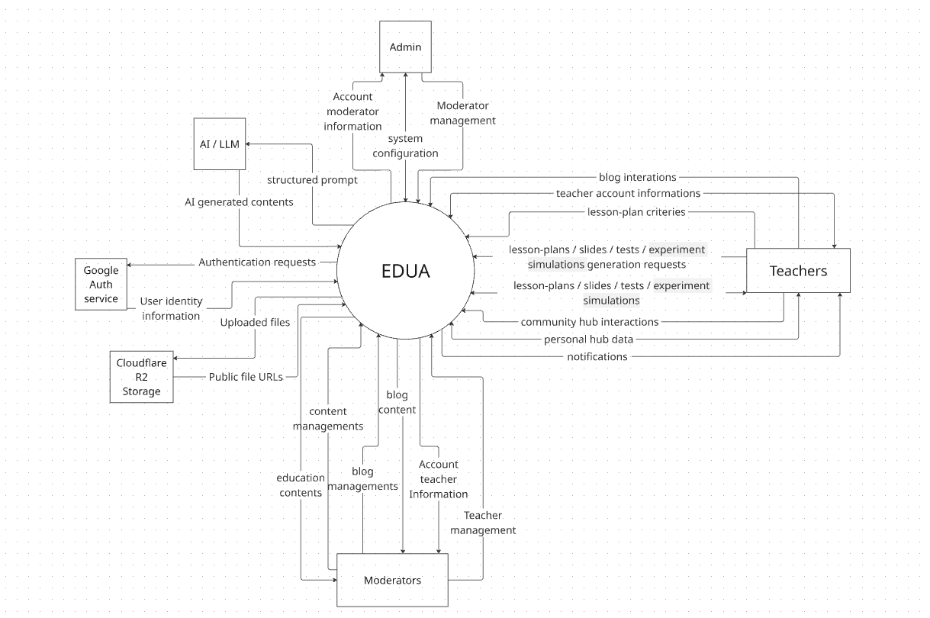

1.2 Main Workflows

1.2.1 Create lesson plan process
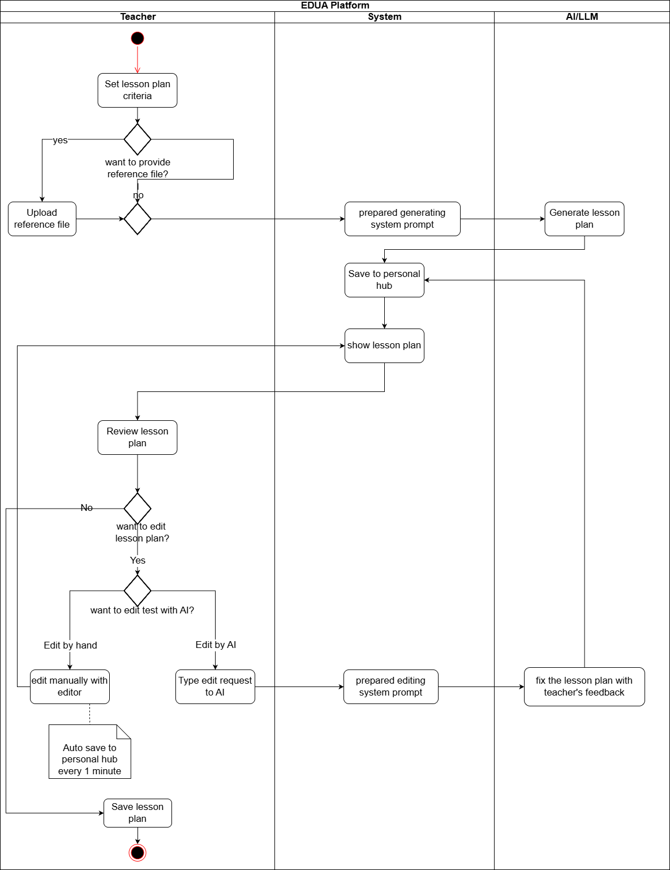

1.2.2 Create slide process
ProjectCode – Report 3 (SRS Document) | Page /18
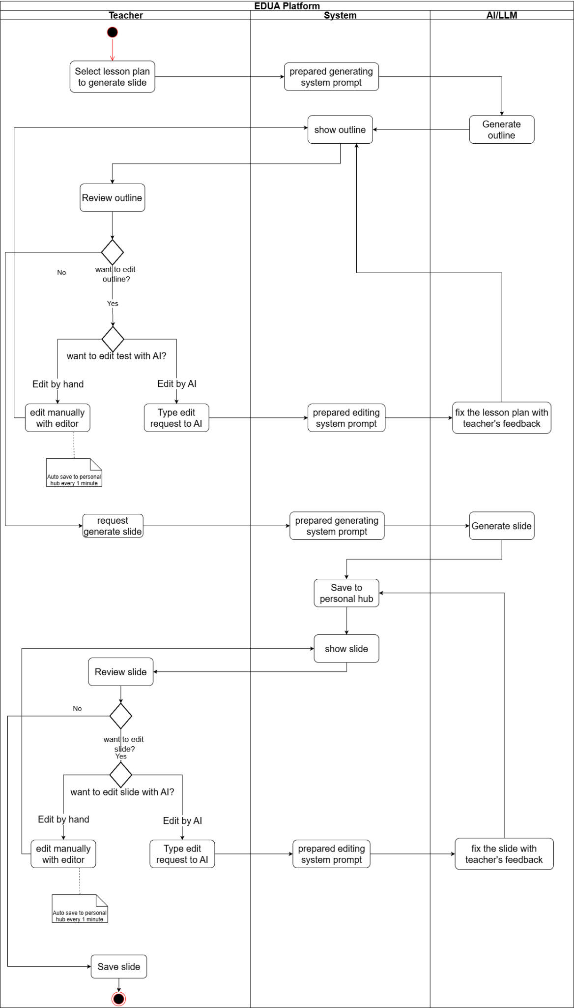

1.2.3 Create test process
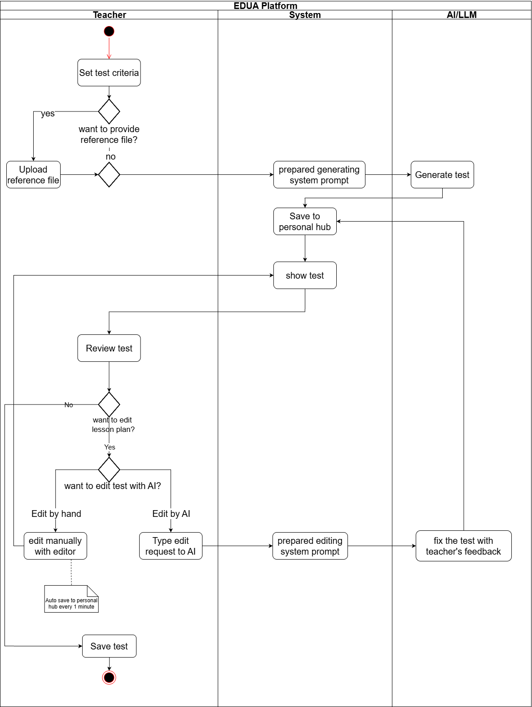

1.3 User Requirements

1.3.1 Actors
# | Actor | Description
1 | Teacher | A STEM teacher (Chemistry, Physics, or Mathematics, grades 10–12) at THPT Lê Quý Đôn Hà Đông — the primary end user and the generalized teacher actor. Represents the capabilities common to all three subjects; subject-level specialization into Math Teacher, Physics Teacher, and Chemistry Teacher is shown in the use case diagrams in section 1.3.3.4. Manages their own account, generates and edits lesson plans, slides, and tests, presents content in class, maintains a personal library, shares and interacts with content in the Community Hub, and writes and discusses posts on the Blog.
2 | Math Teacher | A Mathematics teacher (grades 10–12) at THPT Lê Quý Đôn Hà Đông. Inherits all capabilities of Teacher with no additional subject-specific simulation features (Mathematics has no virtual lab or phenomena hub).
3 | Physics Teacher | A Physics teacher (grades 10–12) at THPT Lê Quý Đôn Hà Đông. Inherits all capabilities of Teacher and additionally accesses the Physics Hub: browses the library of interactive physics phenomena, views phenomenon details, and customizes or generates new simulation variants with AI assistance for their lessons.
4 | Chemistry Teacher | A Chemistry teacher (grades 10–12) at THPT Lê Quý Đôn Hà Đông. Inherits all capabilities of Teacher and additionally accesses the Chemistry Lab: runs virtual experiments, views the interactive periodic table and 3D atomic models, and generates 3D organic molecule models with AI assistance for their lessons.
5 | Moderator (Head of Subject Department) | A head of subject department (e.g., Chemistry, Physics, or Mathematics) who manages their department within EDUA: grant and revoke permissions for teacher accounts of their subject, reviews content submitted to the Community Hub of that subject and approves or rejects it, and removes violating blog posts of that subject.
6 | Administrator | A staff user who manages moderator accounts (grant and revoke access), manages the AI system prompts and master data, views and filters the system activity log, and views user activity records to oversee overall platform operation.
7 | AI / LLM Service | An external AI service (OpenAI/DeepSeek) that receives structured prompts from EDUA and returns AI-generated content for lesson plans, slides, tests, and simulation descriptions.
8 | Authentication Service | An external identity service (Google OAuth2 service) that handles authentication requests and returns user identity information for sign-in and role-based authorization.
9 | File Storage Service | An external object-storage service (Cloudflare R2) that stores uploaded and generated files and returns public file URLs for retrieval.
10 | User | The generalized authenticated actor — any signed-in user of the platform (Teacher, Moderator, or Administrator). Used to group common authenticated capabilities such as login, logout, view and update profile, and view notifications.

1.3.2 Use Cases (UC)
ID | Use Case | Feature | Use Case Description
UC-01 | View Landing Page | Common | A guest or any visitor opens the public homepage to learn about the platform, its features, and available teaching tools.
UC-02 | Login | Authentication | A permission-granted user (teacher, moderator, or admin) signs in with Google to access role-based features of the system.
UC-03 | Logout | Authentication | A permission-granted user ends their session and securely logs out of the system, clearing their authenticated access.
UC-04 | Update Profile Information | Authentication | A permission-granted user views and edits their personal profile details (such as display name, avatar, and contact information) so their account stays accurate.
UC-05 | View My Notifications | Notifications | A permission-granted user opens their notification panel to view system and activity notifications (such as moderation results, comments, or announcements).
UC-06 | View Content List | Moderation | A moderator opens the moderation queue to view the list of user-submitted content that is pending review before it can be published to the community.
UC-07 | View Content Detail | Moderation | A moderator selects a pending item from the queue to view its full detail to evaluate whether it meets the platform's standards for approval to the community hub.
UC-08 | Approve Content | Moderation | While reviewing a content item, a moderator approves it so that it becomes publicly available in the Community Hub. Extends View Content Detail.
UC-09 | Reject Content | Moderation | While reviewing a content item, a moderator rejects it and provides a reason so the author is notified that it will not be published. Extends View Content Detail.
UC-10 | View & Filter Activity Log | Administration | An admin opens the activity-log screen and applies filters (by user, action type, or date range) to monitor and audit system activity.
UC-11 | View System Prompts | Administration | An admin views the AI system prompts that drive content-generation features to review how the AI is configured.
UC-12 | Update System Prompts | Administration | An admin edits and saves the AI system prompts to tune how the AI generates lesson plans, slides, tests, and simulations. Extends View System Prompts.
UC-13 | View Teacher List | Moderation | A moderator views the list of teacher accounts in the system to manage teacher membership.
UC-14 | Add Teacher | Moderation | A moderator grants platform access to a teacher by adding their Gmail account and assigning the Teacher role, so the teacher can log in to the platform using their Google account. Extends View Teacher List.
UC-15 | Delete Teacher | Moderation | A moderator revokes platform access from a teacher by removing their Gmail account's permission, preventing that teacher from logging in to the platform. Extends View Teacher List
UC-16 | View Blog List | Blog | A moderator views the list of blog posts whose subject tag matches their assigned subject, in order to oversee blog content in their area.
UC-17 | View Blog Post Detail | Blog | A moderator opens a blog post within their assigned subject to view its full content while moderating blog activity. Extends View Blog List.
UC-18 | Remove Blog Post | Blog | A moderator removes a blog post whose subject tag matches their assigned subject, providing a reason. Extends View Blog Post Detail.
UC-19 | View Notifications | Notifications | A user (Teacher, Moderator and Admin) opens their notification list to view notifications they have received from the platform — such as announcements from their subject moderator, content moderation results, or system messages.
UC-20 | Create Notifications | Notifications | A moderator creates and sends a notification to all teachers in their assigned subject so subject-level announcements and updates can be delivered through the platform.
UC-21 | View Personal Library | Personal Content | A teacher opens their Personal Library to view and manage all the teaching content they have created (lesson plans, slides, tests, and other resources).
UC-22 | View Own Content Detail | Personal Content | A teacher selects one of their own content items to view its full detail and current status, such as private, pending review, rejected, or published.
UC-23 | Submit / Unsubmit Hub Content for Review | Personal Content | A teacher submits their own content to the Community Hub review queue or withdraws it from the publication workflow before it becomes publicly available. Extends View Personal Library.
UC-24 | Create Lesson Plan | Lesson | A teacher creates a new lesson plan with AI assistance, providing topics and requirements so the system generates a structured draft they can refine.
UC-25 | Create Slide Outline | Slide | A teacher creates a slide outline (the structure and key points of a lecture) as the basis for building a full slide deck.
UC-26 | Create Slide Deck | Slide | A teacher generates a full lecture slide deck from a selected lesson plan, with AI assistance, ready for the classroom.
UC-27 | Create Test | Test | A teacher creates a test (a set of questions) for a subject, with AI assistance generating questions and answers.
UC-28 | Edit Lesson Plan | Lesson | A teacher opens an existing lesson plan and edits its content to adjust or improve it.
UC-29 | Edit Slide Outline | Slide | A teacher opens an existing slide outline and edits its structure or key points.
UC-30 | Edit Slide Deck | Slide | A teacher opens an existing slide deck and edits its slides (text, layout, and media).
UC-31 | Edit Test | Test | A teacher opens an existing test and edits its questions, answers, or scoring.
UC-32 | Present Slide Deck | Slide | A teacher launches presentation mode to display their slide deck full screen for teaching in the classroom.
UC-33 | Export Lesson Plan | Lesson | A teacher exports a lesson plan to a downloadable file format (such as PDF or Word) for offline use or printing.
UC-34 | Export Slide | Slide | A teacher exports a slide deck to a downloadable file format (such as HTML) for offline use.
UC-35 | Export Test | Test | A teacher exports a test to a downloadable file format (such as PDF or Word) for printing or distribution.
UC-36 | Update Own Content | Personal Content | A teacher updates the content of a resource they own to keep it current.
UC-37 | Delete Own Content | Personal Content | A teacher deletes one of their own content items, removing it from their Personal Library.
UC-38 | Create Blog Post | Blog | A teacher creates a new blog post to share teaching experience, subject knowledge, or classroom ideas with other teachers on the platform.
UC-39 | Edit Own Blog Post | Blog | A teacher edits a blog post they authored to update or correct its content.
UC-40 | Delete Own Blog Post | Blog | A teacher deletes a blog post they authored, removing it from the platform.
UC-41 | Create Blog Comment | Blog | A teacher writes a comment on a blog post to discuss or respond to the post content.
UC-42 | Edit Own Blog Comment | Blog | A teacher edits a comment they previously posted on a blog post.
UC-43 | Delete Own Blog Comment | Blog | A teacher deletes a comment they previously posted on a blog post.
UC-44 | View Community Hub | Community Hub | A teacher browses the Community Hub to discover teaching resources publicly shared by other teachers.
UC-45 | View Public Hub Content Detail | Community Hub | A teacher opens a publicly shared content item to view its full detail before reusing or customizing it. Extends View Community Hub.
UC-46 | Customize Content Detail | Community Hub | A teacher creates a personal copy of a public content item and customizes it for their own teaching needs. Extends View Public Hub Content Detail.
UC-47 | View Content's Comments | Community Hub | A teacher views the comments left by the community on a content item. Extends View Public Hub Content Detail.
UC-48 | Update Comment | Community Hub | A teacher edits a comment they previously posted on a community content item. Extends View Content's Comments.
UC-49 | Delete Comment | Community Hub | A teacher deletes a comment they previously posted on a community content item. Extends View Content's Comments.
UC-50 | Delete Comment on Own Content | Community Hub | As the owner of a content item, a teacher deletes any comment left by others on that item to moderate the discussion on their own content.
UC-51 | View Blog | Blog | A teacher views the list of community blog posts to read articles shared by other teachers on the platform.
UC-52 | View Blog Post Detail | Blog | A teacher opens a blog post to read its full content and comments.
UC-53 | View physics Hub | Physics Hub | A Physics teacher browses the Physics Hub to explore the library of interactive physics phenomena and simulations available for their lessons.
UC-54 | View physics Detail | Physics Hub | A Physics teacher opens a specific physics phenomenon to view its detailed simulation and explanation.
UC-55 | Customize Physics Phenomenon | Physics Hub | A Physics teacher customizes an existing physics phenomenon or generates a new simulation variant with AI assistance to fit their lesson. Extends View physics Detail.
UC-56 | Run Chemistry Virtual Lab Experiment | Chemistry Lab | A Chemistry teacher runs a chemistry experiment in the virtual lab by combining substances, and the system predicts and displays the resulting reaction.
UC-57 | View Periodic Table | Chemistry Lab | A Chemistry teacher opens the interactive periodic table to look up elements and their properties.
UC-58 | View 3D Atomic Model | Chemistry Lab | A Chemistry teacher views a 3D atomic model of a selected element to illustrate atomic structure in class.
UC-59 | Generate 3D Organic Molecule Model | Chemistry Lab | A Chemistry teacher inputs an organic compound, and the system generates an interactive 3D molecular model with AI assistance for teaching.
UC-60 | View Moderator List | Administration | An admin views the list of moderator accounts in the system to manage moderator membership.
UC-61 | Add Moderator | Administration | An admin grants platform access to a moderator by adding their Gmail account and assigning the Moderator role, so the moderator can log in and manage their assigned subject. Extends View Moderator List.
UC-62 | Delete Moderator | Administration | An admin revokes platform access from a moderator by removing their Gmail account's permission, preventing that moderator from logging in to the platform. Extends View Moderator List.

1.3.3 Use Case Diagrams

1.3.3.1 UCs for User
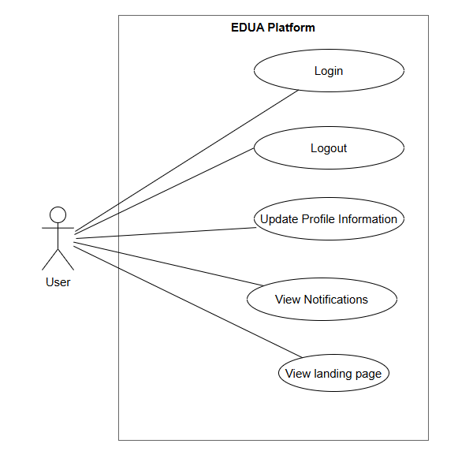

1.3.3.2 UCs for Admin
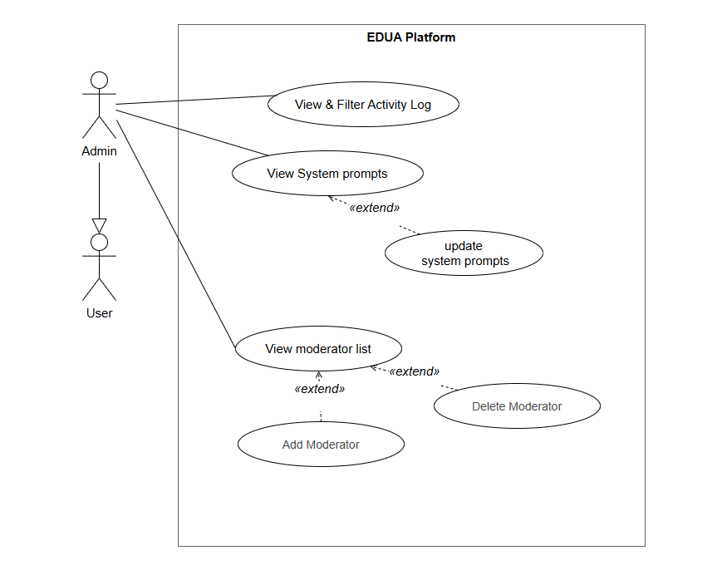

1.3.3.3 UCs for Moderator
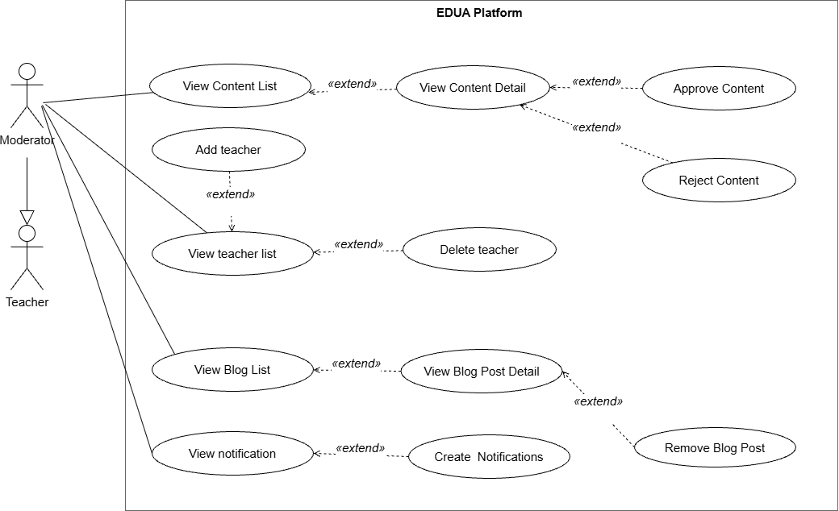

1.3.3.4 UCs for Teacher

1.3.3.4.1 UCs for Math Teacher

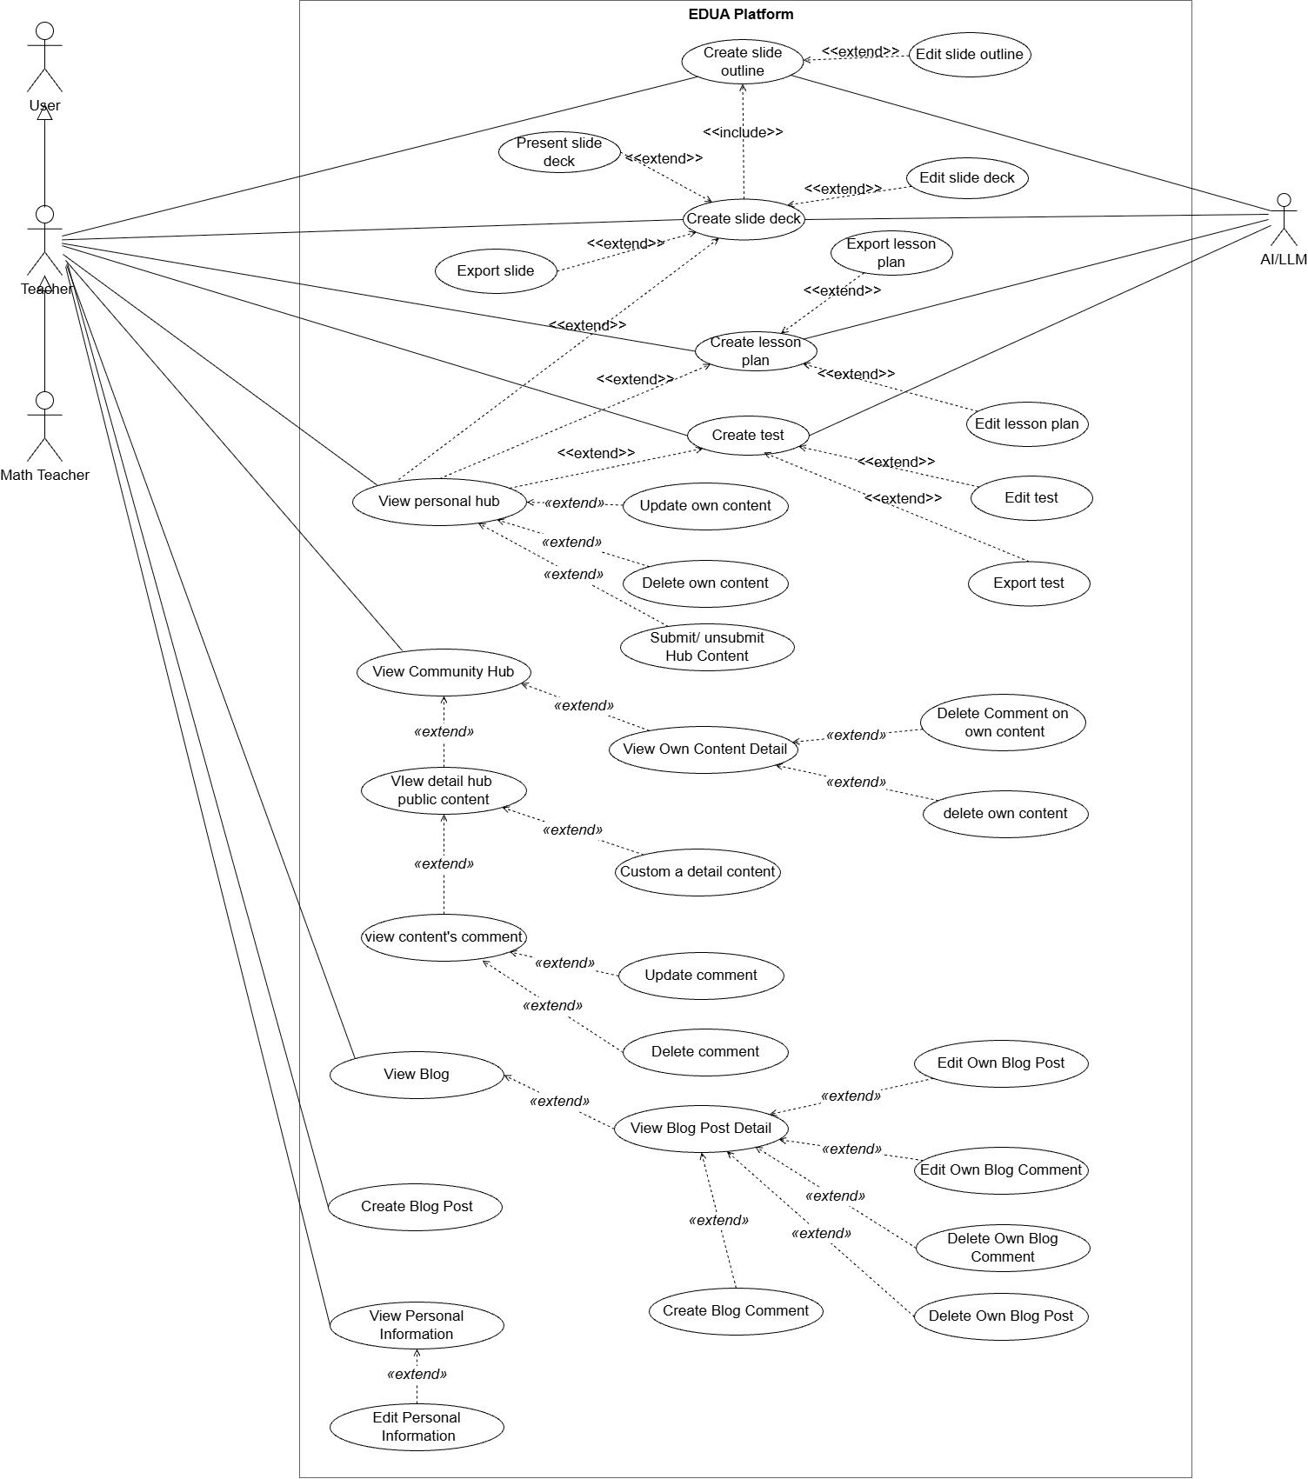

1.3.3.4.2 UCs for Physics Teacher
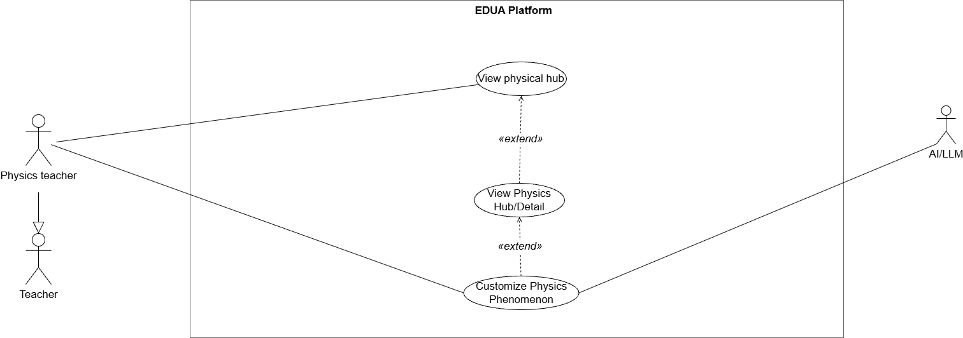

1.3.3.4.3 UCs for Chemistry Teacher
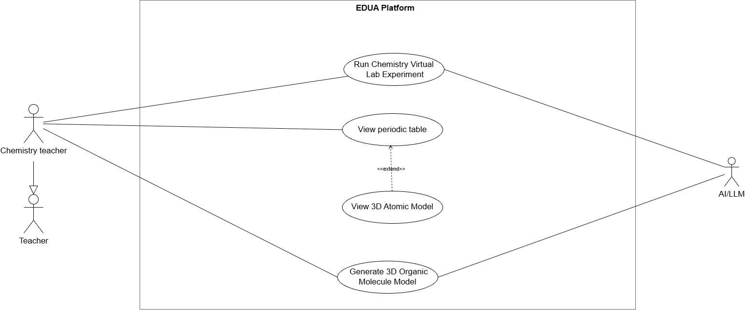

1.4 System Functionalities

1.4.1 Screens Flow

1.4.1.1 Screens Flow for Teacher
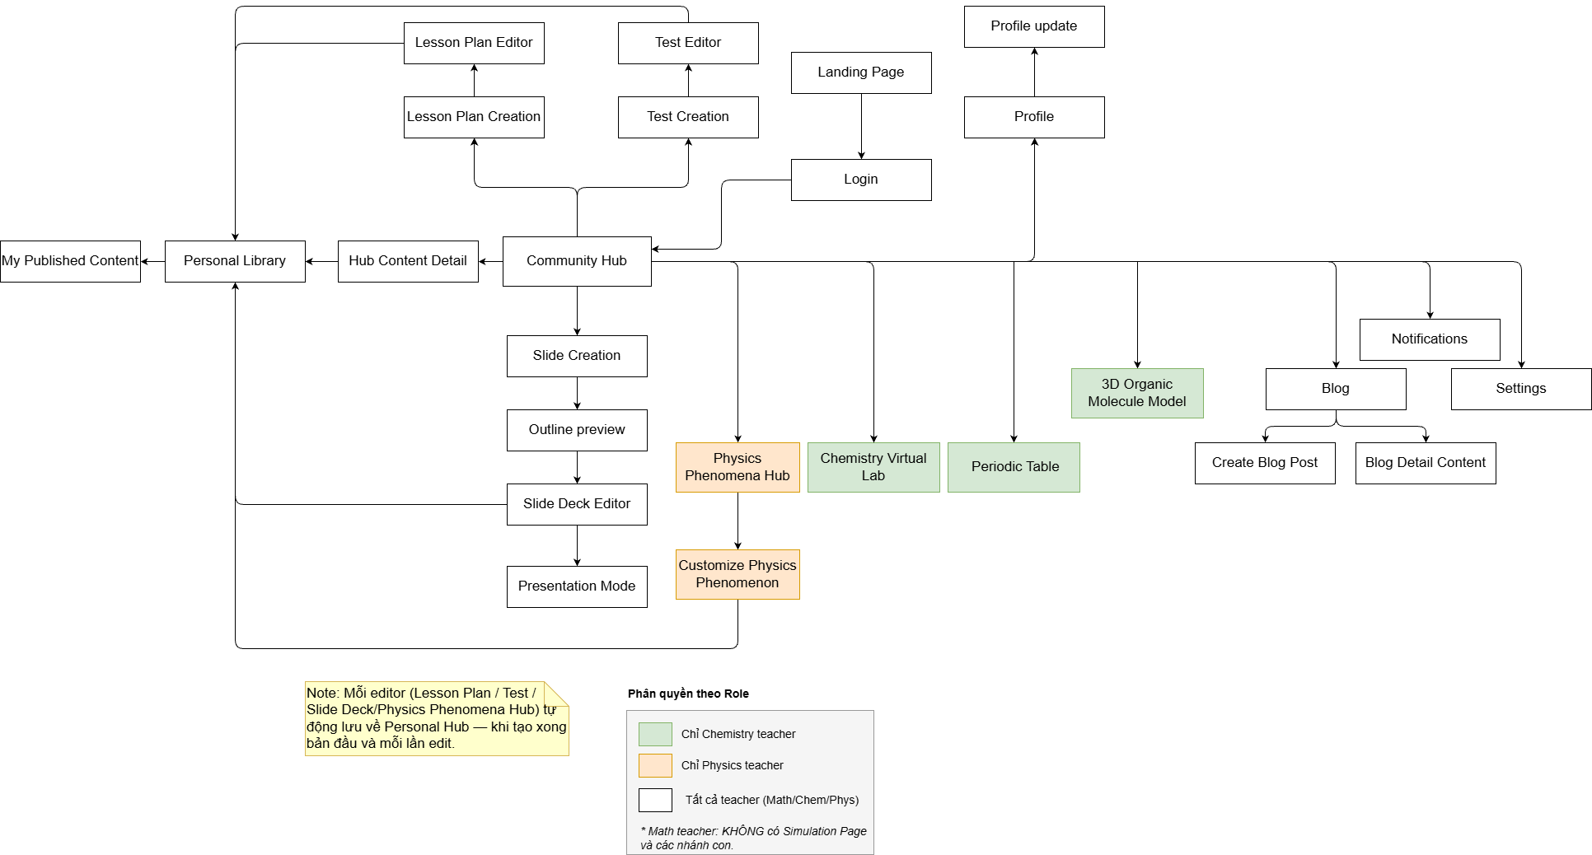

1.4.1.2 Screens Flow for Moderator
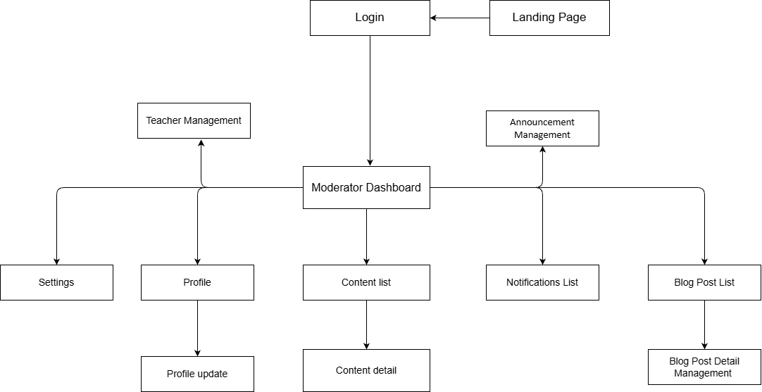

1.4.1.3 Screens Flow for Admin

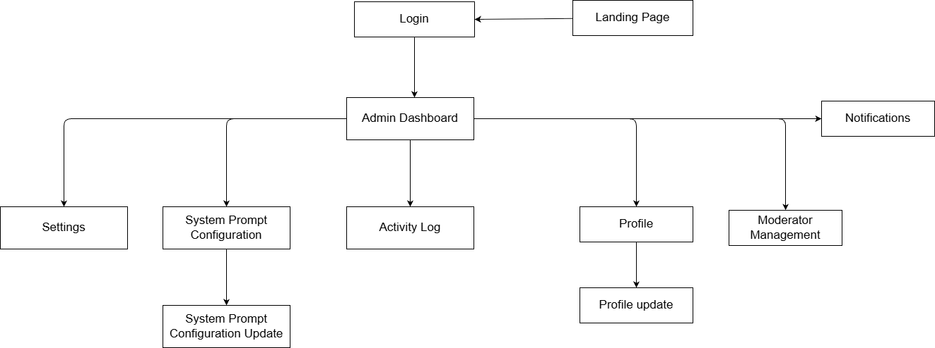

1.4.2 Screen Authorization
Screen | Math Teacher | Chemistry Teacher | Physics Teacher | Moderator | Administrator
Landing Page | X | X | X | X | X
Login | X | X | X | X | X
Community Hub | X | X | X
Lesson Plan Creation | X | X | X
Lesson Plan Editor | X | X | X
Test Creation | X | X | X
Test Editor | X | X | X
Slide Creation | X | X | X
Outline preview | X | X | X
Slide Deck Editor | X | X | X
Presentation Mode | X | X | X
Chemistry Virtual Lab |  | X
Periodic Table |  | X
3D Organic Molecule Model |  | X
Physics Phenomena Hub |  |  | X
Customize Physics Phenomenon |  |  | X
Personal Library | X | X | X
My Published Content | X | X | X
Hub Content Detail | X | X | X
Moderator Dashboard |  |  |  | X
Content List |  |  |  | X
Content Detail |  |  |  | X
Blog | X | X | X
Blog Detail Content | X | X | X
Create Blog Post | X | X | X
Blog Post List |  |  |  | X
Blog Post Detail Management |  |  |  | X
Announcement Management |  |  |  | X
Teacher Management |  |  |  | X
Admin Dashboard |  |  |  |  | X
System Prompt Configuration |  |  |  |  | X
System Prompt Configuration Update |  |  |  |  | X
Activity Log |  |  |  |  | X
Profile | X | X | X | X | X
Profile Update | X | X | X | X | X
Settings | X | X | X | X | X
Notifications | X | X | X |  | X
Moderator List |  |  |  |  | X
Notifications List |  |  |  | X

1.4.3 Non-UI Functions

# | Feature | System Function | Description
1 | Authentication | Identity Provider Integration | Handles user login via Google OAuth2 and session/token validation, and stores the identity in user_profiles.
2 | Authentication | Role-based Authorization | Resolves the signed-in user's roles from user_roles and enforces screen/feature permissions on every request.
3 | Lesson | AI Lesson Plan Generation | Calls the AI/LLM service (OpenAI/DeepSeek) to generate a draft lesson plan from the selected textbook / chapter / lesson and returns structured content to the Lesson Plan Editor.
4 | Slide | AI Slide Deck Generation | Calls the AI/LLM service to generate a slide deck from a selected lesson plan and returns the slide content to the Slide Deck Editor.
5 | Test | AI Test Generation | Calls the AI/LLM service to generate test questions from a lesson plan or an uploaded lesson file.
6 | Simulation | AI Simulation Refinement | Sends the teacher's prompt to the AI/LLM service to adjust a physics/chemistry simulation and returns the updated simulation parameters.
7 | Personal Library | File Storage Service (Cloudflare R2) | Uploads, stores and serves generated artifacts (lesson plans, slide decks, media) and returns access URLs to the application.
8 | Community Hub | Content Moderation Workflow | Routes content submitted for publishing into the moderation queue (Hub Content Review List) for moderator approval or rejection.
9 | Notifications | Notification Dispatch | Generates and delivers in-app notifications (e.g. content approved/rejected, account status changes) to the relevant users.
10 | Administration | Activity / Audit Logging | Records user and system actions (logins, content changes, moderation decisions, account changes) to the activity log for administrator review.
11 | Lesson / Slide / Test | Asynchronous AI Generation Processing | Queues long-running AI generation requests and processes them asynchronously so the UI can poll for results without blocking the user.
12 | Personal Library | Scheduled Storage Cleanup | Periodic background job that removes temporary and unreferenced files from the storage service (Cloudflare R2) to reclaim space.

1.5 Entity Relationship Diagram
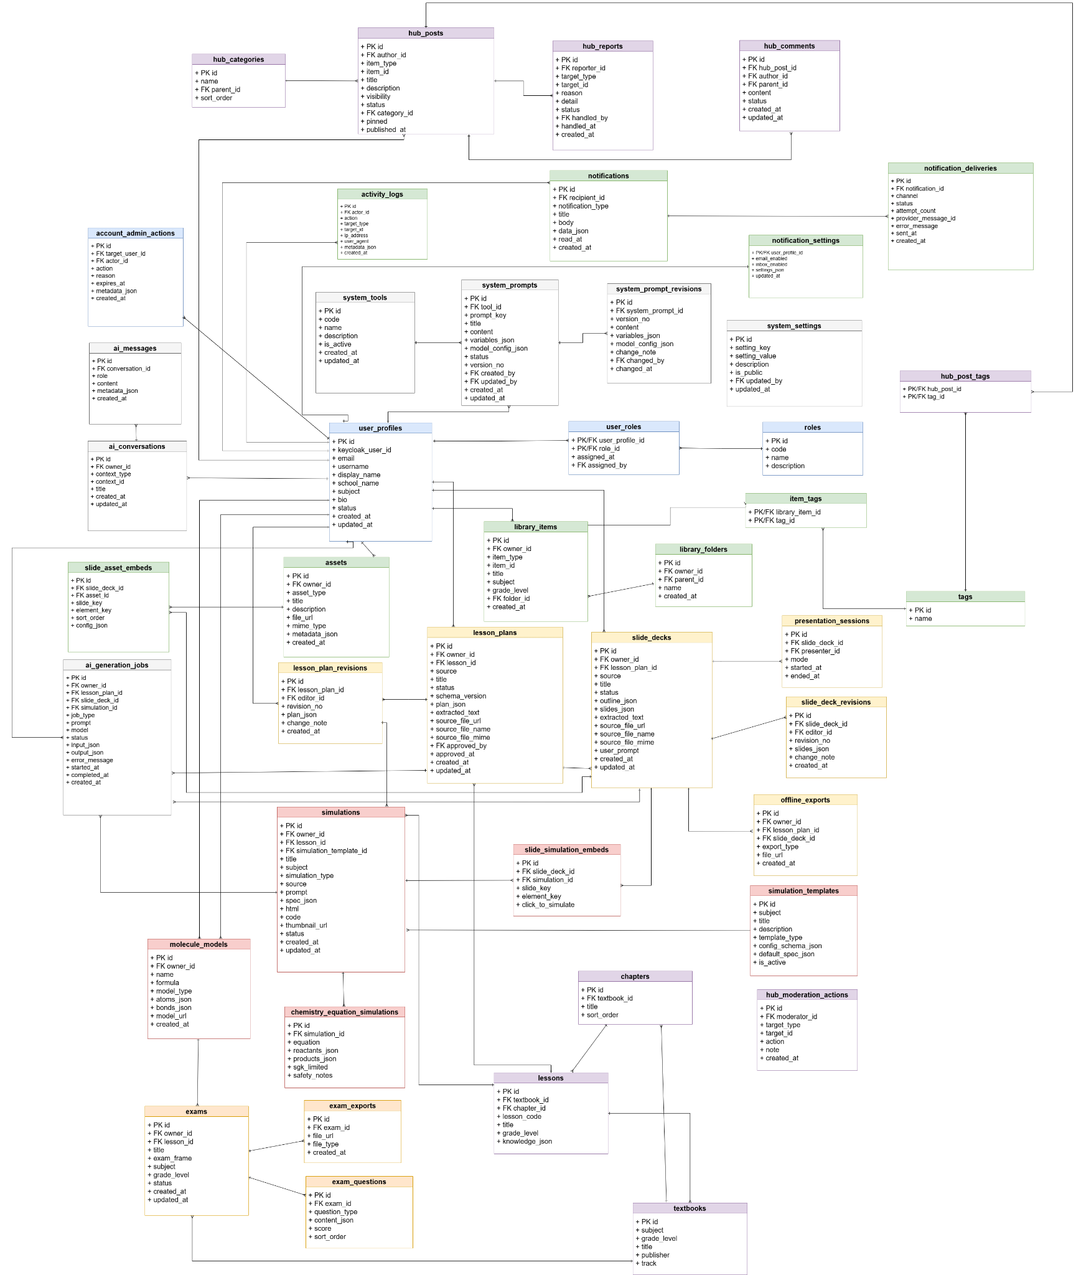


Entities Description

# | Entity | Description
1 | user_profiles | Teacher account profiles (email, username, display name, school, subject, status).
2 | roles | Catalog of system roles defining permission levels (e.g. admin, teacher).
3 | user_roles | Junction table assigning roles to users, with who granted them and when.
4 | textbooks | Textbook catalog organized by subject and grade level.
5 | chapters | Chapters belonging to a textbook, with title and display order.
6 | lessons | Lessons within a textbook/chapter, including lesson code, grade level and knowledge data.
7 | lesson_plans | Teacher-authored lesson plans built from lessons.
8 | lesson_plan_revisions | Version history of lesson plans, tracking each saved change.
9 | slide_decks | Presentation slide decks (title, status, outline/slides data, source file, owner).
10 | slide_deck_revisions | Version history of slide decks, recording each editor's revision and change note.
11 | presentation_sessions | Live presentation/teaching sessions running a slide deck (presenter, mode, start/end time).
12 | offline_exports | Offline export files (e.g. PDF/HTML) generated from lesson plans and slide decks.
13 | assets | Uploaded media assets (images, files) owned by users.
14 | slide_asset_embeds | Junction linking assets embedded into specific slides.
15 | library_folders | Folders that organize a user's content library.
16 | library_items | Items stored in a user's content library.
17 | tags | Catalog of reusable tags/labels.
18 | item_tags | Junction linking library items to tags.
19 | simulations | Interactive simulations created for lessons.
20 | simulation_templates | Reusable templates used to create simulations.
21 | chemistry_equation_simulations | Chemistry equation simulations (balancing/reaction visualisations).
22 | molecule_models | 3D molecule models used in chemistry content.
23 | slide_simulation_embeds | Junction linking simulations embedded into slides.
24 | exams | Exams / tests authored by teachers.
25 | exam_questions | Questions belonging to an exam.
26 | exam_exports | Exported exam files generated for printing/sharing.
27 | hub_categories | Categories used to organize community hub posts.
28 | hub_posts | Community hub posts shared by users.
29 | hub_comments | Comments left on hub posts.
30 | hub_reports | Reports/flags raised against hub content for moderation.
31 | hub_moderation | Moderation records/decisions on community hub content (review actions, status).
32 | hub_post_tags | Junction linking hub posts to tags.
33 | notifications | Notifications generated for users.
34 | notification_settings | Per-user notification preferences.
35 | notification_deliveries | Delivery records of notifications across channels (in-app, email, etc.).
36 | activity_logs | Audit log of user activity across the system.
37 | account_admin_actions | Administrative actions performed on user accounts.
38 | system_tools | Registered system/AI tools available to the platform.
39 | system_prompts | System prompt templates used by AI features.
40 | system_prompt_revisions | Version history of system prompts.
41 | system_settings | Global system configuration settings.
42 | ai_generation_jobs | Records/queue of AI content-generation jobs and their status.
43 | ai_conversations | AI chat conversations between users and the assistant.
44 | ai_messages | Individual messages within an AI conversation.

2. Use Case Specifications

2.1 Lesson

2.1.1 Create Lesson Plan
Primary Actors | Teacher | Secondary Actors | AI/LLM , File Storage Service
Description | As a teacher, I want to generate a MOET-5512 lesson plan from textbook data with AI assistance so that I can prepare a lesson quickly.
Preconditions | The teacher is signed in (BR-04) and on the Lesson Plan Creation screen.
Postconditions | An AI-generated lesson plan is created and auto-saved to the Personal Library as a draft (BR-19); its status is Private.
Normal Sequence/Flow | Generate Lesson Plan  - The teacher selects Subject / Grade / Lesson from the textbook knowledge base (BR-07).  - The teacher optionally enters additional objectives or custom AI requirements before submitting.  - The teacher submits the generation request.  - The system sends a structured prompt to the AI/LLM Service and shows a generating message (MSG06).  - AI/LLM Service returns the generated lesson plan content.  - The system renders the lesson plan in the Lesson Plan Editor and auto-saves it to the Personal Library (BR-19).  - The system shows a success message (MSG14).
Alternative Sequences/Flows | Step 3_Upload document file:  Beside selecting Subject / Grade / Lesson, the teacher uploads a lesson plan file from the device; the system validates the file type/size (MSG13) and uses it as the input source.  Step 5_Required field missing:  If a required field (Subject / Grade / Lesson) is empty when the teacher submits, the system blocks generation and shows an inline validation error (MSG02).  Step 6_AI generation fails:  The AI/LLM Service returns an error or times out; the system shows a failure message (MSG07) and lets the teacher retry.

2.1.2 Edit Lesson Plan
Primary Actors | Teacher | Secondary Actors | AI/LLM , File Storage Service
Description | As a teacher, I want to edit a generated lesson plan manually or through an AI prompt so that I can refine its content before using it.
Preconditions | Teacher is signed in (BR-04); a lesson plan is open in the Lesson Plan Editor (continued from UC-24 or opened from Personal Library).
Postconditions | The updated lesson plan is auto-saved to the Personal Library (BR-19). Its publication status is handled according to the content editing status rule (BR-23).
Normal Sequence/Flow | Edit Lesson Plan  - Teacher continues from UC-24 (Create Lesson Plan) with the newly generated lesson plan already open in the Lesson Plan Editor.  - The system displays the lesson plan content in the Lesson Plan Editor.  - The teacher edits the content manually (sections, activities, objectives).  - The system validates the changes and auto-saves the lesson plan to the Personal Library (BR-19).  - The system shows a success message (MSG08).
Alternative Sequences/Flows | Step 1 — Open from Library:  Instead of continuing from UC-24, the teacher opens a saved lesson plan from the Personal Library.  Step 3_Edit via AI prompt:  Instead of editing manually, the teacher enters a free-form AI prompt; the system sends it to the AI/LLM Service (MSG06), applies the returned changes, and shows the updated content.  Step 4_AI generation fails:  The AI/LLM Service returns an error or times out; the system shows a failure message (MSG07) and keeps the last saved version.

2.1.3 Export Lesson Plan
Primary Actors | Teacher | Secondary Actors | File Storage Service
Description | As a teacher, I want to export a lesson plan to a downloadable file (PDF/Word) so that I can use it outside the system.
Preconditions | The teacher is signed in (BR-04) and has a lesson plan open in the Lesson Plan Editor (or selected in the Personal Library).
Postconditions | The lesson plan is downloaded to the teacher's device in the chosen format; the stored lesson plan is unchanged.
Normal Sequence/Flow | Export Lesson Plan  - The teacher opens a lesson plan in the Lesson Plan Editor.  - The teacher selects Export and chooses an output format (PDF / Word).  - The system generates the file in the selected format via the File Storage Service.  - The system downloads the file to the teacher's device.  - The system shows a success message (MSG18).
Alternative Sequences/Flows | Step 1 — Open from Library:  Instead of opening from the Lesson Plan Editor, the teacher selects a saved lesson plan from the Personal Library and the flow resumes at step 2.  Step 3 — Export fails:  The file generation or download fails; the system shows a failure message (MSG07) and lets the teacher retry.

2.2 Test

2.2.1 Create Test
Primary Actors | Teacher | Secondary Actors | AI/LLM , File Storage Service
Description | As a teacher, I want to create a test from textbook data based on chosen criteria with AI assistance so that I can assess my students quickly.
Preconditions | The teacher is signed in (BR-04) and on the Test Creation screen.
Postconditions | An AI-generated test is created and auto-saved to the Personal Library as a draft (BR-19); its status is Private.
Normal Sequence/Flow | Create Test  - The teacher selects Subject / Grade / Lesson from the textbook knowledge base and sets the test criteria (number of questions, difficulty, question types) (BR-07).  - The teacher optionally enters additional objectives or custom AI requirements before submitting.  - The teacher submits the generation request.  - The system sends a structured prompt to the AI/LLM Service and shows a generating message (MSG06).  - AI/LLM Service returns the generated test content.  - System renders the test in the Test Editor and auto-saves it to the Personal Library (BR-19).  - The system shows a success message (MSG15).
Alternative Sequences/Flows | Step 3_Upload document file:  Instead of selecting Subject / Grade / Lesson, the teacher uploads a reference/source file (PDF, DOCX, PPTX); the system validates the file type/size (MSG13) and uses it as the input source.  Step 5_Required field missing:  If a required field (Subject / Grade / Lesson) is empty when the teacher submits, the system blocks generation and shows an inline validation error (MSG02).  Step 6_AI generation fails  The AI/LLM Service returns an error or times out; the system shows a failure message (MSG07) and lets the teacher retry.

2.2.2 Edit Test
Primary Actors | Teacher | Secondary Actors | AI/LLM , File Storage Service
Description | As a teacher, I want to edit a generated test manually or via an AI prompt so that I can adjust the questions before using it.
Preconditions | The teacher is signed in (BR-04) and has a test open in the Test Editor.
Postconditions | The updated test is auto-saved to the Personal Library (BR-19). Its publication status is handled according to the content editing status rule (BR-23).
Normal Sequence/Flow | Edit Test  - Teacher continues from UC-27 (Create Test) with the newly generated test already open in the Test Editor.  - The system displays the test content in the Test Editor.  - The teacher edits questions, answers, or scores manually.  - The system validates the changes and auto-saves the test to the Personal Library (BR-19).  - The system shows a success message (MSG08).
Alternative Sequences/Flows | Step 1 — Open from Library:  Instead of continuing from UC-27, the teacher opens a saved test from the Personal Library.  Step 3_Edit via AI prompt:  The teacher enters an AI prompt to regenerate or refine questions; the system sends it to the AI/LLM Service (MSG06) and applies the returned changes.  Step 4_AI generation fails  The AI/LLM Service returns an error or times out; the system shows a failure message (MSG07) and keeps the last saved version.

2.2.3 Export Test
Primary Actors | Teacher | Secondary Actors | File Storage Service
Description | As a teacher, I want to export a test and its answer key to a printable file so that I can print and distribute it to students.
Preconditions | The teacher is signed in (BR-04) and has a test open in the Test Editor (or selected in the Personal Library).
Postconditions | The test (and answer key) is downloaded to the teacher's device as a printable file; the stored test is unchanged.
Normal Sequence/Flow | Export Test  - The teacher opens a test in the Test Editor.  - The teacher selects Export and chooses the output format (PDF / Word).  - The teacher chooses whether to include the answer key.  - The system generates the printable file via the File Storage Service.  - The system downloads the file to the teacher's device.  - The system shows a success message (MSG18).
Alternative Sequences/Flows | Step 1 — Open from Library:  Instead of opening from the Test Editor, the teacher selects a saved test from the Personal Library and the flow resumes at step 2.  Step 4 — Export fails:  The file generation or download fails; the system shows a failure message (MSG07) and lets the teacher retry.

2.3 Slide

2.3.1 Create Slide Outline
Primary Actors | Teacher | Secondary Actors | AI/LLM
Description | As a teacher, I want to generate a slide outline from a lesson plan with AI assistance so that I can structure my slide deck before generating it.
Preconditions | The teacher is signed in (BR-04) and on the Slide Creation screen with a lesson plan selected as the input source.
Postconditions | An AI-generated slide outline is created and shown in the Slide Outline Preview; it is auto-saved to the Personal Library as part of the slide draft (BR-19).
Normal Sequence/Flow | Create Slide Outline  - The teacher selects a lesson plan from the Personal Library as the input source.  - The teacher submits the generation request.  - The system sends a structured prompt to the AI/LLM Service and shows a generating message (MSG06).  - AI/LLM Service returns the generated slide outline.  - System renders the outline in the Slide Outline Preview and auto-saves it (BR-19).  - The system shows a success message (MSG17).
Alternative Sequences/Flows | Step 2_Upload document file:  Instead of selecting from the Personal Library, the teacher uploads a lesson plan file from their device; the system validates file type/size (MSG13) and uses it as the input source.  Step 6_AI generation fails  The AI/LLM Service returns an error or times out; the system shows a failure message (MSG07) and lets the teacher retry.

2.3.2 Edit Slide Outline
Primary Actors | Teacher | Secondary Actors | AI/LLM
Description | As a teacher, I want to edit the generated slide outline so that I can adjust the structure before generating the slide deck.
Preconditions | The teacher is signed in (BR-04) and has a slide outline open in the Slide Outline Preview.
Postconditions | The updated slide outline is auto-saved to the Personal Library (BR-19).
Normal Sequence/Flow | Edit Slide Outline  - Teacher continues from UC-25 (Create Slide Outline); the system displays the newly generated outline in the Slide Outline Preview.  - The system displays the outline content.  - The teacher edits the outline items manually (add, remove, reorder, or rename sections).  - The system validates the changes and auto-saves the outline (BR-19).  - The system shows a success message (MSG08).
Alternative Sequences/Flows | Step 3_Edit via AI prompt:  The teacher enters an AI prompt to restructure the outline; the system sends it to the AI/LLM Service (MSG06) and applies the returned changes.  Step 4_AI generation fails:  The AI/LLM Service returns an error or times out; the system shows a failure message (MSG07) and keeps the last saved version.

2.3.3 Create Slide Deck
Primary Actors | Teacher | Secondary Actors | AI/LLM, File Storage Service
Description | As a teacher, I want to generate a slide deck from a slide outline with AI assistance so that I can prepare presentation slides quickly.
Preconditions | The teacher is signed in (BR-04) and has confirmed a slide outline in the Slide Outline Preview.
Postconditions | An AI-generated slide deck is created and auto-saved to the Personal Library as a draft (BR-19); its status is Private.
Normal Sequence/Flow | Create Slide Deck  - The teacher confirms the slide outline and submits the slide-deck generation request.  - The system sends a structured prompt to the AI/LLM Service and shows a generating message (MSG06).  - AI/LLM Service returns the generated slide content.  - The system renders the slide deck in the Slide Deck Editor and auto-saves it to the Personal Library (BR-19).  - The system shows a success message (MSG16).
Alternative Sequences/Flows | Step 3_AI generation fails:  The AI/LLM Service returns an error or times out; the system shows a failure message (MSG07) and keeps the last saved version.

2.3.4 Edit Slide Deck
Primary Actors | Teacher | Secondary Actors | AI/LLM, File Storage Service
Description | As a teacher, I want to edit a generated slide deck manually or via an AI prompt so that I can refine the slides before presenting.
Preconditions | The teacher is signed in (BR-04) and has a slide deck open in the Slide Deck Editor.
Postconditions | The updated slide deck is auto-saved to the Personal Library (BR-19). Its publication status is handled according to the content editing status rule (BR-23).
Normal Sequence/Flow | Edit Slide Deck  - Teacher continues from the Create Slide Deck flow (UC-26); the slide deck is already open in the Slide Deck Editor.  - The system displays the slide deck in the Slide Deck Editor.  - The teacher edits slide content manually (text, images, layout, slide order).  - The system validates the changes and auto-saves the slide deck (BR-19).  - The system shows a success message (MSG08).
Alternative Sequences/Flows | Step 1_Open from Personal Library:  At step 1, instead of continuing from the Create Slide Deck flow, the teacher opens an existing slide deck from the Personal Library; the system displays it in the Slide Deck Editor and the flow resumes at step 3.  Step 3_Edit via AI prompt:  The teacher enters an AI prompt to adjust the slides; the system sends it to the AI/LLM Service (MSG06) and applies the returned changes.  Step 4_AI generation fails:  The AI/LLM Service returns an error or times out; the system shows a failure message (MSG07) and keeps the last saved version.

2.3.5 Export slide
Primary Actors | Teacher | Secondary Actors | File Storage Service
Description | As a teacher, I want to export a slide deck to a downloadable file (HTML for offline use) so that I can present or use it outside the system.
Preconditions | The teacher is signed in (BR-04) and has a slide deck open in the Slide Deck Editor (or selected in the Personal Library).
Postconditions | The slide deck is downloaded to the teacher's device in the chosen format; the stored slide deck is unchanged.
Normal Sequence/Flow | Export Slide Deck  - The teacher opens a slide deck in the Slide Deck Editor.  - The teacher selects Export and chooses an output format (HTML).  - The system generates the file via the File Storage Service.  - The system downloads the file to the teacher's device.  - The system shows a success message (MSG18).
Alternative Sequences/Flows | Step 1 — Open from Library:  Instead of opening from the Slide Deck Editor, the teacher selects a saved slide deck from the Personal Library and the flow resumes at step 2.  Step 3 — Export fails:  The file generation or download fails; the system shows a failure message (MSG07) and lets the teacher retry.

2.4 Common

2.4.1 View Landing Page
Primary Actors | Guest / Teacher | Secondary Actors | None
Description | As a visitor, I want to view the landing page so that I can learn about the system and decide to sign in or get started.
Preconditions | None — the landing page is publicly accessible.
Postconditions | The landing page is displayed; the visitor may proceed to sign in or to another screen.
Normal Sequence/Flow | View Landing Page  1. The visitor navigates the system's URL.  2. The system displays the landing page (product introduction, key features, call-to-action).  3. The visitor browses the content.  4. The visitor selects a call-to-action (e.g., Sign in / Get started).  5. The system navigates to the selected screen.
Alternative Sequences/Flows | Step 4 — Stay on page:  The visitor takes no action and remains on the landing page.

3. Functional Requirements

3.1 Lesson

3.1.1 Create lesson

3.1.1.1 Lesson Plan Creation
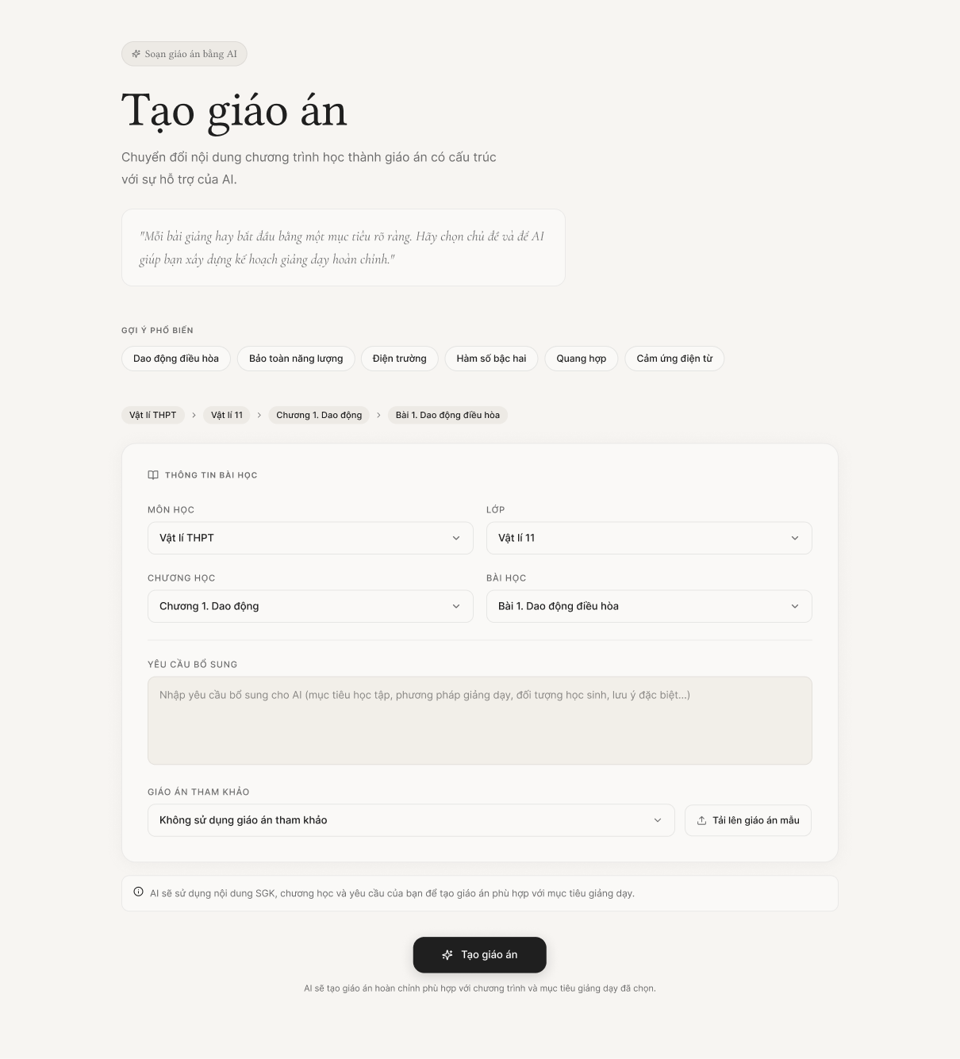
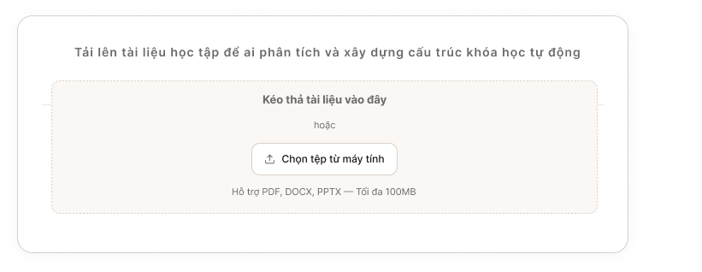
This screen allows the teacher to set up the curriculum context parameters and configuration constraints so the AI system can automatically generate a draft lesson plan aligned with the MOET Circular 5512 standards. Teachers can quickly select from popular topic suggestions or manually define the curriculum hierarchy (Subject $\rightarrow$ Grade $\rightarrow$ Chapter $\rightarrow$ Lesson) based on the official textbook database. Additionally, the system provides a feature to upload reference teaching materials, allowing the AI to analyze specific context data before generating the detailed lesson plan content.
Mapped Use Case(s):
- UC-24: Create Lesson Plan
The Lesson Plan Creation screen allows the Teacher to:
- View and select popular suggested topic tags to quickly populate lesson details.
- Select the exact pedagogical context via cascading dropdowns (Subject, Grade, Chapter, Lesson) derived from the official textbook database.
- Choose the configuration method: Use existing textbook data as the sole input or upload custom reference files.
- Upload supporting teaching materials (e.g., sample lesson plans, reading materials) via a drag-and-drop interface or file selection (supporting .pdf, .docx, .pptx formats).
- Submit the generation request for the AI to process asynchronously, which automatically redirects the user to the Lesson Plan Editor screen upon completion.

Field Description
Field Name | Description
Quick Suggestions | Displays suggested lesson topics to help the teacher start faster. Clicking a suggestion may auto-fill part of the lesson information form.
Suggestion Item | Displays a suggested lesson topic, such as “Bài giảng về Định luật Newton” or other recommended lesson ideas.
Section Title – Lesson Information | Displays the main form section title: “Thông tin bài giảng” / “Lesson Information”.
Subject | Required dropdown field. Allows the teacher to select the subject for the lesson plan, such as Physics, Chemistry, or Mathematics.
Grade | Required dropdown field. Allows the teacher to select the grade level, such as Grade 10, Grade 11, or Grade 12.
Chapter | Required dropdown field. Allows the teacher to select the chapter belonging to the chosen subject and grade. The available chapter list depends on the selected subject and grade.
Lesson / Topic Title | Required text input field. Allows the teacher to enter the lesson name or topic title. Example: “Newton’s First, Second, and Third Laws and Applications”.
Additional Objectives | Optional multi-line text area. Allows the teacher to enter additional requirements, expected outcomes, or custom teaching objectives for the lesson plan.
Reference Document Section | Displays the status of the input reference document.
Upload Document Button | Triggers the system file dialog or expands the drag-and-drop overlay area to allow the teacher to upload a reference file.
Generate Lesson Plan with AI Button | Submits the form and sends the selected information to the AI generation service. If all required fields are valid, the system generates a draft lesson plan and redirects the teacher to the Lesson Plan Editor screen.

3.1.1.2 Lesson Plan Editor

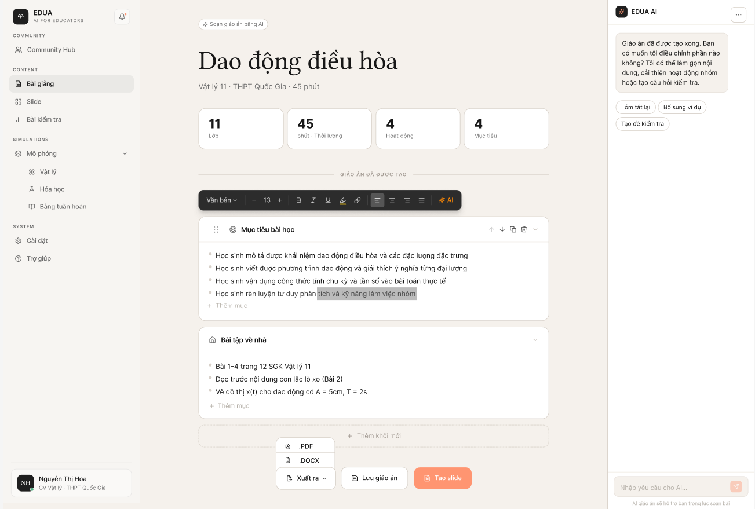

This screen allows the teacher to review and refine the lesson plan generated by the AI service. At the top, a summary highlights key metrics like grade level, duration, and the number of activities. The generated content is displayed as a structured list of lesson sections, shown here in an expanded state to reveal detailed bullet points for objectives, teaching methods, and materials. On the right side, an interactive AI sidebar enables the teacher to easily modify the content. The teacher can use quick-action buttons to simplify text, add group activities, or generate questions, or use the chat input to request specific, direct adjustments to the lesson plan from the AI.
Mapped Use Case(s):
- UC-24: Create Lesson Plan
- UC-28: Edit Lesson Plan
- UC-25: Create Slide Outline
- UC-33: Export Lesson Plan
The Lesson Plan Editor screen allows the Teacher to:
- View the AI-generated lesson plan title and summary information.
- View the lesson structure in a section-based format.
- Edit an existing lesson section.
- Input AI Prompt to configure lesson plan, summary information and lesson section.
- Export lesson as a PDF or DOCX file.

Field Description
Field Name | Description
Lesson Plan Title | Displays the title of the current lesson plan.
Lesson Metadata Summary | Displays summary information such as subject, grade, and lesson duration.
Information Panel | Displays supporting lesson information such as learning objectives, lesson duration, and target students.
Main Editor Area | Displays the generated lesson plan sections in editable blocks.
Section Card | Represents one lesson plan section, such as Learning Objectives, Preparation, Teaching Process, or Homework.
Export button | A drop-down button allow teacher to download lesson as a PDF or DOCX file
Save button | Allow teacher to save lesson plan to personal hub
Create Slide Deck Button | A shortcut button allow teacher to use lesson plan to make slide deck
AI chat sidebar | Allow teacher to use AI to edit lesson plan

3.2 Slide

3.2.1 Create Slide

3.2.1.1 Slide Creation
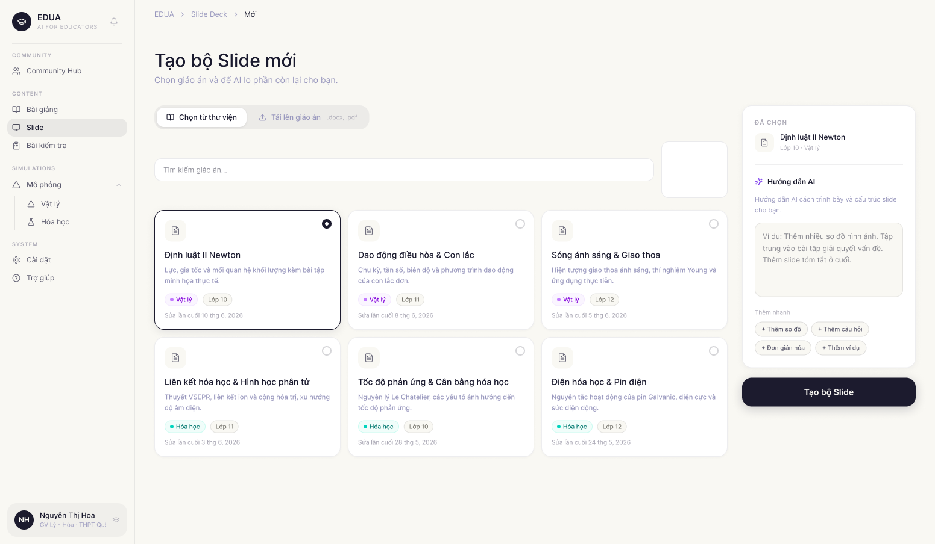
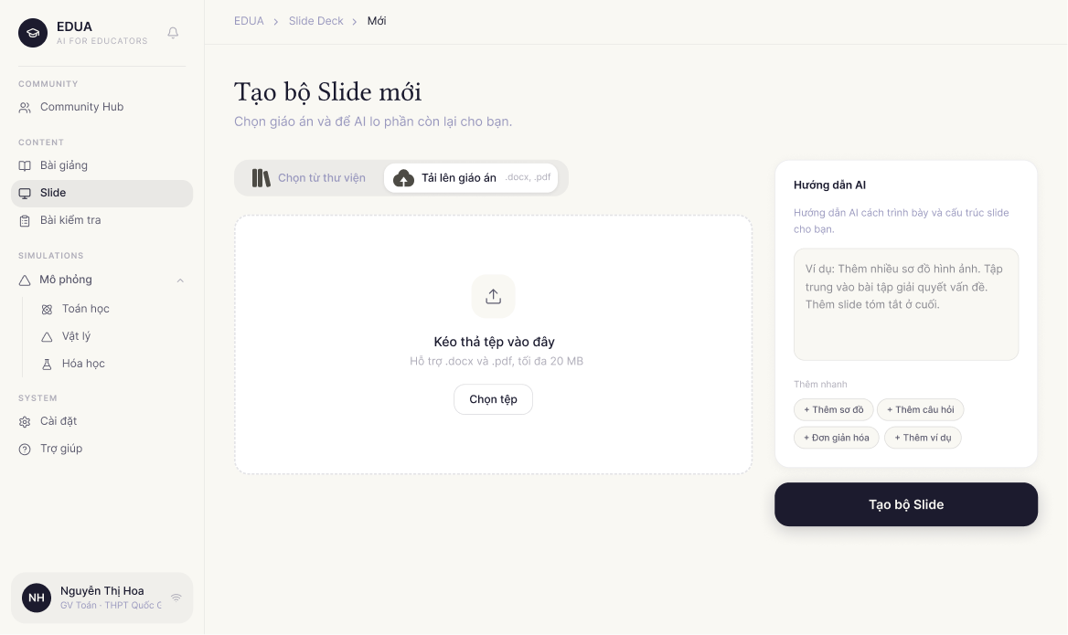
This screen allows the teacher to generate a slide deck with AI based on an existing lesson plan. The teacher selects a lesson plan from the available list, optionally provides additional requirements or style instructions for the AI, and submits the request to generate a slide deck. After the generation process is completed, the system redirects the teacher to the Slide Deck Editor screen.
Mapped Use Case(s):
- UC-25: Create Slide Outline
- UC-26: Create Slide Deck
The Slide Creation screen allows the Teacher to:
- View available lesson plans that can be used as the source content.
- Select one lesson plan as the input for slide generation.
- View basic metadata of each lesson plan, such as subject, grade, and created/updated date.
- Enter additional requirements for AI slide generation.
- Use suggested AI prompts to quickly customize the slide output.
- Generate a slide deck from the selected lesson plan.
Field Description
Field Name | Description
Select Lesson Plan Section | Displays the list of existing lesson plans that the teacher can use as the source input for slide generation.
Lesson Plan Card | Displays one available lesson plan, including title, subject, grade, and created/updated date.
Selected Lesson Plan State | Highlights the lesson plan currently selected by the teacher. Only one lesson plan can be selected at a time.
Lesson Search Box | Text input for user to type and find lesson’name
Lesson Plan Icon | Displays an icon representing a lesson plan resource.
Lesson Plan Title | Displays the name of the lesson plan, such as “Ba Định luật Newton”.
Subject Tag | Displays the subject of the lesson plan, such as Physics, Chemistry, or Mathematics.
Grade Information | Displays the grade level associated with the lesson plan, such as Grade 10.
Created / Updated Date | Displays the date when the lesson plan was created or last updated.
Additional AI Requirements Panel | Allows the teacher to describe extra style, content, or design requirements that should be considered when generating the slide deck.
AI Suggestion Item | Represents one suggested requirement. When clicked, the suggestion can be added to the AI requirement input.
AI Requirement Input | Optional text input field. The teacher can enter custom instructions for the AI, such as preferred slide style, additional activities, target audience, or visual requirements.
Generate Slide Button | Submits the selected lesson plan and additional AI requirements to the AI generation service. If the input is valid, the system starts generating the slide deck and redirects the teacher to the Slide Deck Editor when the result is ready.
Upload Button | Allows the teacher to upload the document and use AI to create slide base on following contents

3.2.1.2 Slide Outline Preview
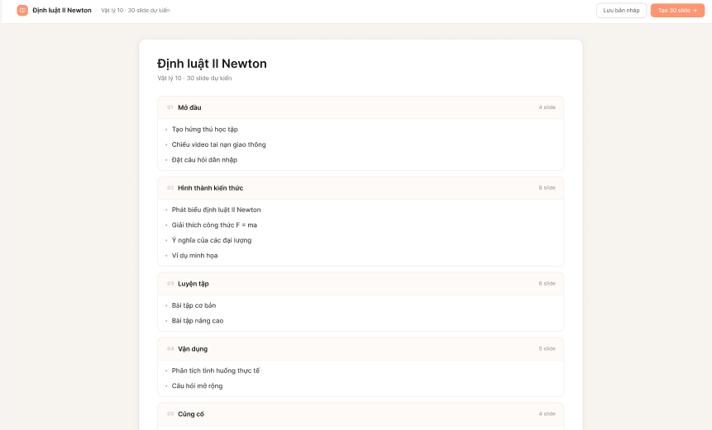

This screen allows the teacher to review and refine the logical structure of the slide deck before the full visual content is generated by the AI. The outline is organized into pedagogical sections (e.g., Introduction, Knowledge Formation, Practice, Application) derived from the approved lesson plan. Teachers can customize the presentation flow by adding or removing sections, adding or deleting individual slides, and reordering content to better fit their classroom needs.
Mapped Use Case(s):
- UC-25: Create Slide Outline
The Slide Outline Preview screen allows the Teacher to:
- View the overall summary of the proposed deck (Total sections and Total slides).
- Review the titles and categories of all slides grouped within specific lesson phases.
- Edit the titles of sections and individual slides.
- Reorder slides or entire sections using a drag-and-drop interface.
- Add new pedagogical sections or additional slides to existing sections.
- Delete unnecessary slides or sections.
- Navigate back to the Lesson Plan Editor if adjustments to the source material are needed.
- Submit the finalized outline to trigger the full AI Slide Deck Generation.

Field Description
Field Name | Description
Outline Title | Displays the name of the lesson plan used for generation
Outline Summary | Displays the current structure statistics.
Section Card | A container representing a major phase of the lesson.
Section Title Editor | An editable text field for the title of the pedagogical phase.
Slide Item Row | Represents a single slide, teacher can click into item to open edit modal
Slide Title Input | An editable text field for the title of an individual slide.
Delete Icon | Removes the specific slide or section from the outline.
Add Slide Button | Adds a new blank slide entry to the bottom of the current section.
Add Section Button | Adds a new pedagogical section card to the bottom of the outline.
Generate Slides Button | Triggers the AI generation process to create the full visual slide deck based on the finalized outline.

3.2.1.3 Slide Outline Editor
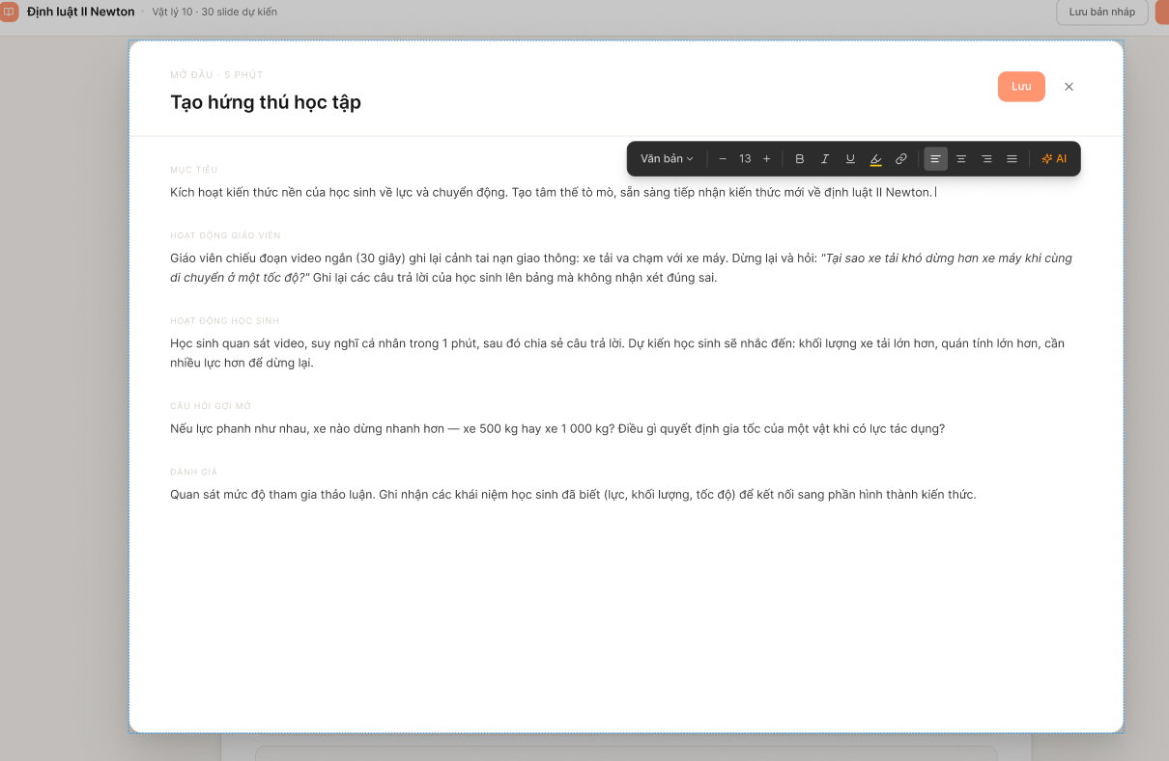
This screen provides an interface for the teacher to refine the text content and structural blocks of each slide in the outline. The teacher can quickly browse the list of slides, select a specific slide to directly modify its title, edit the content of text blocks (headings, paragraphs), or add new content blocks in the central editing canvas.
Mapped Use Case(s):
- UC-29: Edit Slide Outline
The Slide Outline Preview screen allows the Teacher to:
- Modify the title of the selected slide to better match the lesson content.
- Edit the text inside the component blocks of the slide (Heading blocks, Paragraph blocks).

Field Description
Field Name | Description
Slide Title Input | A text input field in the main editing area, displaying and allowing modifications to the main title of the selected slide.
Paragraph Block Input | A multi-line text area allowing the teacher to draft detailed content, explanations, or core knowledge definitions to be displayed on the slide.
Save Button | Allow the teacher to save editing session
X Button | Allows the teacher to cancel the current editing session and return to the previous configuration interface.

3.2.1.4 Slide Deck Editor
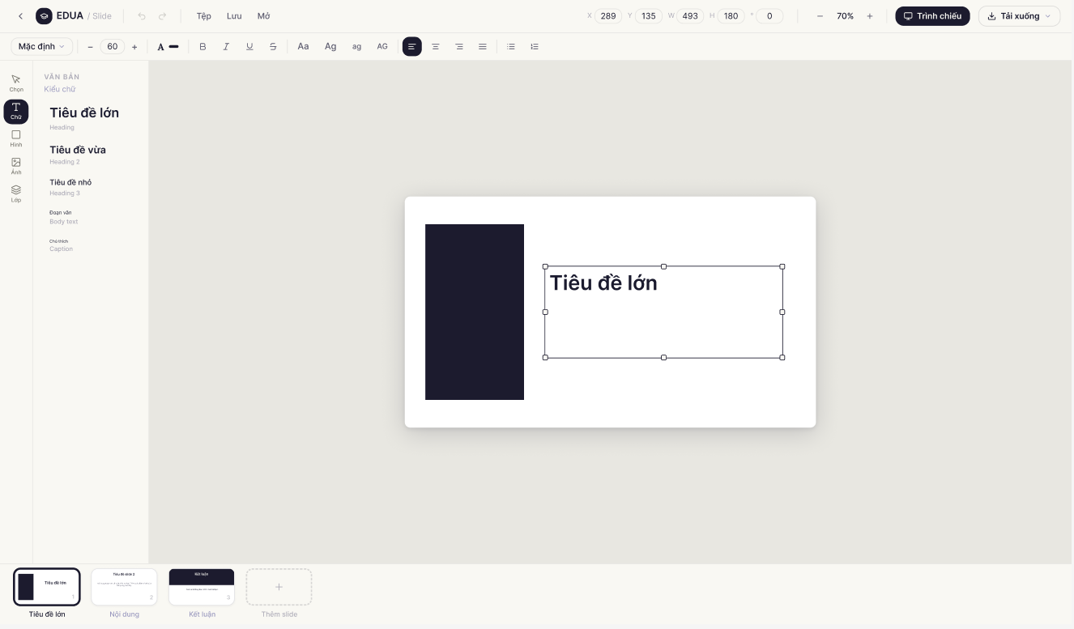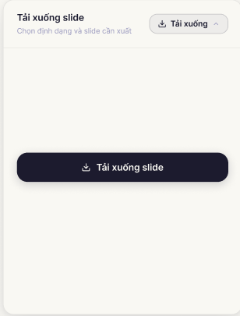
This screen allows the teacher to review, edit, and organize the slide deck generated by the AI service from the selected lesson plan. The teacher can navigate through slides, edit slide content, add visual elements, adjust formatting, apply transitions, duplicate or delete slides, download the slide deck or start presentation mode.
Mapped Use Case(s):
- UC-26: Create Slide Deck
- UC-30: Edit Slide Deck
- UC-32: Present Slide Deck
- UC-34: Export Slide
The Slide Deck Editor screen allows the Teacher to:
- View the AI-generated slide deck.
- Navigate between slides using the slide thumbnail list.
- Edit text content and formatting.
- Add elements such as text, images, shapes, circles, and charts.
- Change visual settings such as color and alignment.
- Duplicate or delete the current slide.
- Apply slide transition effects.
- Change zoom level and grid view.
- Export the slide deck.
- Share the slide deck if permitted.
- Present the slide deck in presentation mode.
Field Description
Field Name | Description
Back Button | Returns the teacher to the previous screen or slide list.
Slide Deck Title | Displays the title of the current slide deck generated from the lesson plan.
Top Toolbar | Provides formatting and editing controls for the selected slide element.
Text Formatting Controls | Allows the teacher to apply text formatting such as bold, italic, underline, and alignment.
Color Control | Allows the teacher to change the color of selected text, shapes, or slide elements.
Zoom Control | Displays and adjusts the current zoom percentage of the slide canvas.
Grid View Button | Shows or hides grid layout support to help align slide elements.
Present Button | Opens the slide deck in presentation mode for classroom presentation.
Export File Button | A drop-down popup allows the teacher to choose export options.
Download FIle Button | A button allow teacher to download slide deck.
Slide Thumbnail Panel | Displays all slides in the deck as thumbnails on the left side. The teacher can select a slide to edit.
Slide Thumbnail | Displays a small preview of a slide, including slide order number. Clicking a thumbnail opens that slide in the main canvas.
Selected Slide State | Highlights the currently selected slide in the thumbnail panel.
Main Slide Canvas | Displays the selected slide in editable form. The teacher can edit text, layout, and visual elements directly on this canvas.
Slide Navigation Indicator | Displays the current slide number and total number of slides, such as “1 / 10”.
Previous / Next Slide Control | Allows the teacher to move to the previous or next slide.
Add Elements Panel | Provides tools for adding new elements to the current slide.
Text Element Button | Adds a text box to the current slide.
Image Element Button | Adds an image to the current slide.
Shape / Box Element Button | Adds a rectangular shape or box to the current slide.
Circle Element Button | Adds a circular shape to the current slide.
Chart Element Button | Adds a chart or diagram element to the current slide.
Current Slide Actions | Provides actions that affect the selected slide.
Duplicate Slide Button | Creates a copy of the current slide.
Delete Slide Button | Deletes the current slide after confirmation.
Transition Effects Panel | Allows the teacher to apply animation or transition effects to the current slide.
Transition Effect Option | Displays available transition effects such as Fade, Slide, Zoom, or Flip.

3.3 Test

3.3.1 Create Test

3.3.1.1 Test Creation
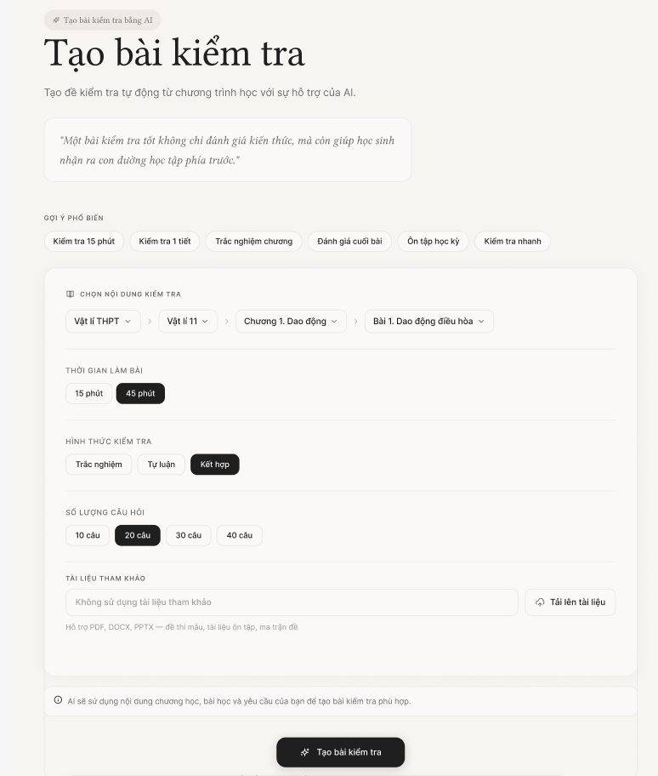

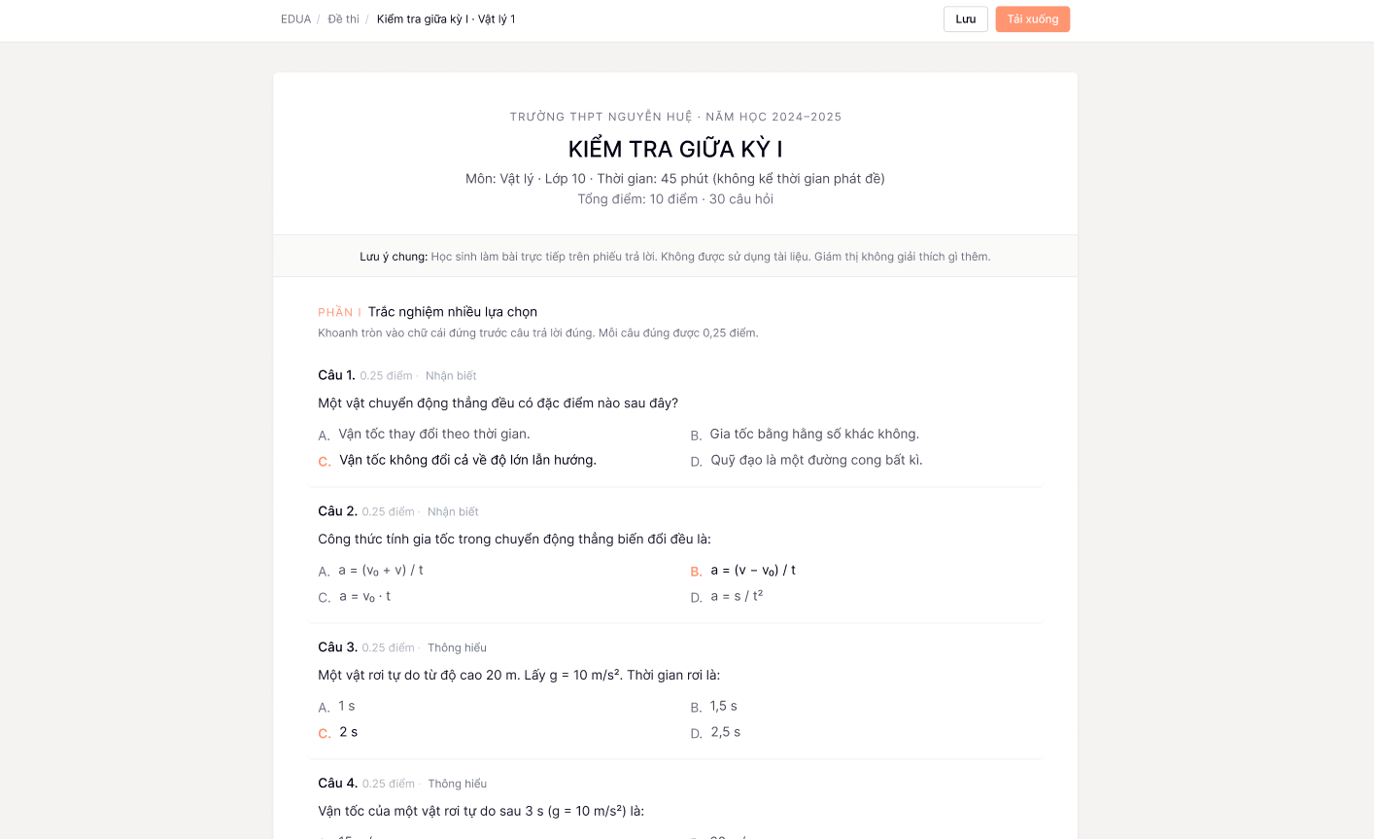
This screen allows the teacher to configure and generate an AI-assisted test or quiz by providing curriculum parameters and specific test constraints. The teacher can choose from popular topic suggestions or manually select the subject, grade, chapter, and lesson. Additionally, the screen provides detailed configurations for the test, including duration, difficulty level, total number of questions, and question types. Users can also upload reference materials or input custom AI instructions before submitting the generation request.
Mapped Use Case(s):
- UC-27: Create Test
The Test Creation screen allows the Teacher to:
- View quick suggestions for common test topics.
- Select the curriculum context (Subject, Grade, Chapter, Lesson).
- Configure the test duration (e.g., 15 minutes, 45 minutes, Mid-term).
- Adjust the difficulty level using a slider.
- Set the total number of questions.
- Select the desired question types (Multiple choice, True/False, Essay/Short answer).
- Enter additional AI instructions for test generation.
- Upload reference files to base the test on.
- Submit the form to generate the test with AI.
- Export the test as a printable document (e.g., PDF/DOCX) for offline use.
Field Description
Field Name | Description
Quick Suggestions | Displays suggested test topics. Clicking a suggestion auto-fills the curriculum context.
Subject / Grade / Chapter / Lesson | Dropdown fields allow the teacher to select the exact curriculum context for the test.
Test Duration | Selection chips to define the length of the test (e.g., 15 phút, 45 phút, Giữa kỳ).
Question Types | Checkboxes allowing the teacher to include specific formats: Multiple choice (Trắc nghiệm nhiều lựa chọn), True/False (Đúng sai), and Essay (Tự luận).
Total Questions | Numeric input field to specify how many questions the generated test should contain.
Upload Reference File | Button to upload files (PDF, DOCX, PPTX) that the AI should use as the source material for the test.
AI Instructions | Optional multi-line text area for custom instructions, such as focusing on specific sub-topics or adjusting the tone.
Generate Test Button | Submits the configurations to the AI service to generate the test and redirects to the Test Editor screen.

3.3.1.2 Test Editor

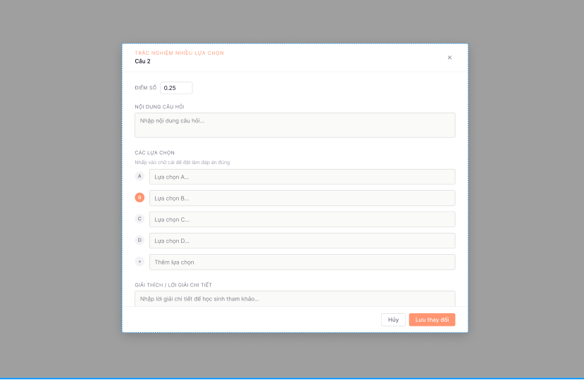

This screen provides an intuitive interface for teachers to review, refine, and organize a generated or uploaded test. The main view displays a structured list of questions categorized logically by format (e.g., Section I: Multiple Choice, Section II: True/False, Section III: Essay).
To streamline the editing process, the screen incorporates an Edit Question Modal. This modal appears as an overlay directly on the main canvas whenever the teacher clicks on a specific question, allowing for detailed manual adjustments without navigating away from the full test view.
Mapped Use Case(s):
- UC-31: Edit Test
- UC-35: Export Test
The Test Editor screen allows the Teacher to:
- View the test title and metadata summary (Grade, Subject, Duration, Total Questions, Max Score).
- Review the list of questions organized by sections.
- Click on any specific question card to open the Edit Question Modal.
- Adjust the point value (score) for individual questions.
- Modify the question content, answer options, and designate the correct answer(s) within the modal.
- Write or edit detailed step-by-step solutions or explanations for each question.
- Save the current state of the test to the Personal Library.
- Export the test as a printable document (e.g., PDF/DOCX) for offline use.
Field Description
Field Name | Description
Export Button | Allows the teacher to download the test and its answer key as a printable document (.docx, .pdf).
Test Title | Displays the title of the current test (e.g., "Bài kiểm tra Dao động cơ học 1"). Allows the teacher to edit the title directly.
Metadata Summary | Displays fixed parameters of the test including: Grade, Subject, Duration (e.g., 45 minutes), Total Questions, and Total Score.
Section Header | Divides the test into major sections based on question types (e.g., Section I: 4-option Multiple Choice).
Question Card Item | Displays a preview of the question text, available options, point value, and correct answer indicator. Clicking this area triggers the Edit Question Modal.
Save Button | Manually saves the current state and edits of the test to the teacher's Personal Library.
Edit Question Modal | An overlay modal that appears when a Question Card is clicked. It includes the following fields:
Score Input | Numeric input field allowing the teacher to adjust the specific point value/weight of the selected question.
Question Text Editor | A rich text editor area to modify the main text of the question, including formatting, math formulas, or symbols.
Correct Answer Selector | Radio buttons (or checkboxes) placed next to each option to allow the teacher to define which answer is correct.
Answer Option Input | Text fields containing the content of each choice (A, B, C, D).
Add Option Button | A button to add a new blank answer option to the question.
Solution Editor | A rich text editor area to provide the step-by-step solution, explanation, or grading rubric for the question.
Cancel Button | Closes the modal and discards any unsaved changes made to the question during the current editing session.
Save Changes Button | Applies the edits to the question, updates the main Test Editor view, and closes the modal.

3.4 Landing Page

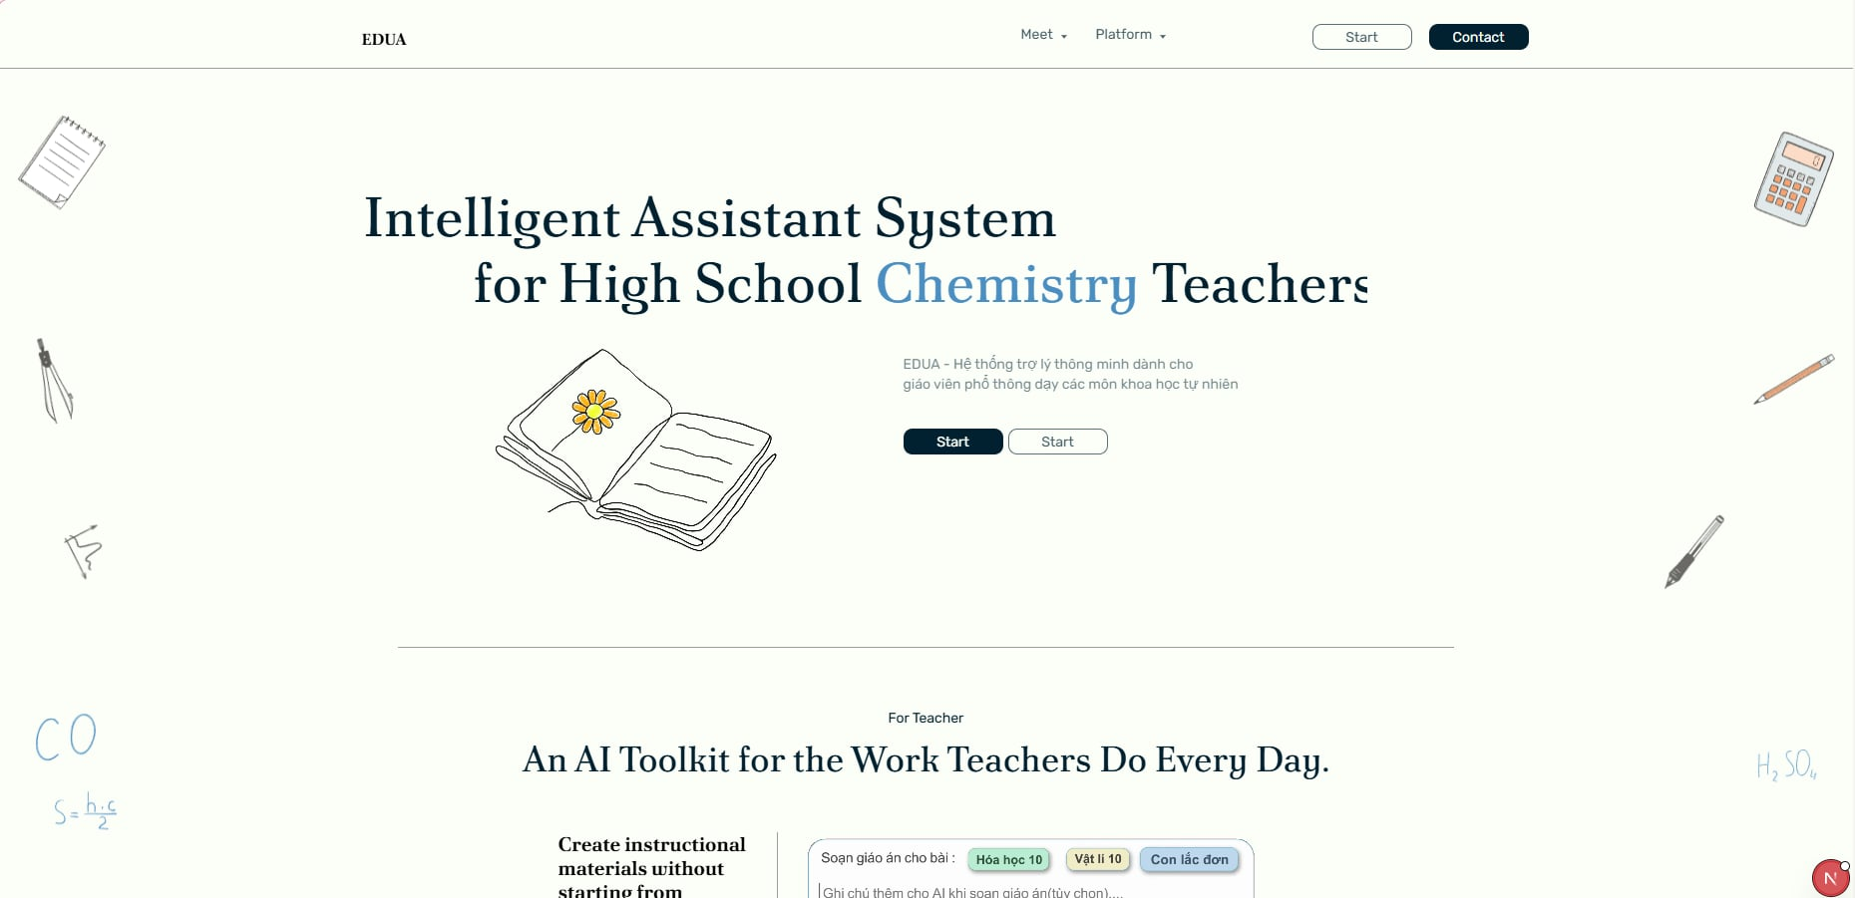
This is the public-facing homepage and primary entry point of the EDUA platform. It introduces the platform's core AI-assisted capabilities tailored for teachers, including automated lesson plan generation, smart slides, interactive 2D/3D simulations, and AI test creation. The screen serves as a marketing and navigation hub, guiding unauthenticated users (guests) to learn about EDUA and proceed to the authentication flow (Login). Guests can only access the Landing Page; all other features require granted access and sign-in. Because EDUA does not support self-registration, access is granted internally by authorized staff.
Mapped Use Case(s):
- UC-01: View Landing Page
- UC-02: Login
The Landing Page allows a Guest to:
- View the platform's value proposition, headline, and system mockup.
- Understand the core features through detailed informational cards.
- Understand that platform access is granted internally and contact the assigned moderator or administrator if access is needed.
- Start sign-in after access has been granted.
Field Description
Field Name | Description
Top Navigation Bar | The persistent header containing the EDUA logo and quick links to different sections of the landing page ("Trang chủ", "Tính năng", "Về chúng tôi").
Login Button | A secondary button in the top navigation bar that redirects the user to the authentication service to sign in.
Access Request Note | A note or guidance text in the top navigation area that explains users must be granted access before signing in.
Hero Section | The main banner area displaying the primary value proposition ("Trợ lý AI toàn diện cho giáo viên STEM") and a visual mockup of the platform.
Sign In Button | A prominent Call-To-Action (CTA) button in the Hero section that starts the Google sign-in flow.
Features Section | A section displaying individual cards that highlight the four core pillars of the platform: Automated Lesson Plans, Smart Slides, Interactive Simulations, and AI Tests.
Access Guidance Section | A dedicated block explaining that EDUA access is limited to granted teacher, moderator, and administrator accounts.

4. Non-Functional Requirements

4.1 External Interfaces
User Interfaces: EDUA is accessed through modern web browsers (Google Chrome 90+, Mozilla Firefox 88+, Microsoft Edge 90+, Safari 14+) on desktop and laptop devices. The interface is optimized for screen resolutions of 1280×720 and above. All user-facing screens follow a consistent layout with a left-side navigation bar, top header bar, and main content area as defined in the Screen Flow (Section 1.4.1).
Hardware Interfaces: No specialized hardware is required. The system runs on standard computing devices (PC, laptop) with a minimum of 4 GB RAM and a stable internet connection (minimum 2 Mbps download speed). For 3D simulation rendering (Chemistry virtual lab, Physics phenomena), a device with WebGL-capable graphics is recommended.
Software Interfaces: EDUA integrates with the following external services:\n– Google OAuth2 Integration: Handles user login via Google sign-in and issues internal JWT tokens for session management and role-based authorization. User accounts are created by administrators and moderators (by granting access to a Gmail address); the system does not support self-registration.\n– OpenAI/DeepSeek: AI/LLM service — receives structured prompts and returns generated content for lesson plans, slide decks, test questions, and simulation descriptions.\n– Cloudflare R2: Object storage — stores and serves uploaded and generated files (lesson plans, slide decks, images, exported PDFs/PPTX) via signed URLs.
Communication Interfaces: All client–server communication uses HTTPS (TLS 1.2+) over REST APIs with JSON payloads. Asynchronous AI generation jobs use a polling mechanism where the client periodically checks the job status endpoint. In-app notifications are delivered via the server notification dispatch service. File uploads and downloads are routed through signed Cloudflare R2 URLs to avoid exposing storage credentials to the client.

4.2 Quality Attributes

4.2.1 Usability
USR-01: A new teacher user shall be able to complete the first login process (sign in with Google, update profile) within 3 minutes without external assistance.
USR-02: A teacher with no prior training shall be able to generate a lesson plan (select subject → grade → lesson → generate) within 5 minutes of first login.
USR-03: All interactive elements (buttons, links, input fields) shall have visible labels or tooltips. Icon-only controls shall display a descriptive tooltip on hover within 0.5 seconds.
USR-04: Form validation errors shall be displayed inline next to the relevant field immediately upon submission, using red text and an error icon, with a clear description of the required correction.
USR-05: The system shall provide consistent navigation across all screens: a persistent left sidebar for feature navigation and a top header bar showing the user's profile, notifications, and logout option.
USR-06: All AI-generated content (lesson plans, slides, tests) shall be presented in an editable format so the teacher can modify any element before saving or exporting.
USR-07: The system shall support Vietnamese and English UI languages. All system messages, labels, and tooltips shall be available in both languages.

4.2.2 Performance
PRF-01: Standard page loads (login, dashboard, library, hub listing) shall complete rendering within 2 seconds under normal network conditions (≥ 2 Mbps).
PRF-02: AI-assisted lesson plan generation shall return the first draft to the editor within 30 seconds for a single lesson selection. The system shall display a progress indicator during generation.
PRF-03: AI-assisted slide deck generation shall complete within 60 seconds for a lesson plan of up to 10 sections.
PRF-04: AI-assisted test generation shall return generated questions within 30 seconds for a single lesson input.
PRF-05: 3D Chemistry simulation (molecule rendering, reaction animation) shall render at a minimum of 24 frames per second on a device with WebGL 2.0 support.
PRF-06: The system shall support at least 200 concurrent authenticated users without degradation of response times specified above.
PRF-07: File upload (lesson plan import, image attachment) shall accept files up to 100 MB and complete the upload within 10 seconds on a 10 Mbps connection.
PRF-08: Search operations on the Community Hub (keyword search, filter by subject/grade) shall return results within 3 seconds for a dataset of up to 10,000 published posts.

4.2.3 Security
SEC-01: All user authentication shall be handled via Google OAuth2. The system shall not store user passwords. Identity verification is delegated to Google; the system validates the returned OAuth token and checks the user's email against the granted-access list server-side.
SEC-02: All client–server communication shall be encrypted using HTTPS with TLS 1.2 or higher. Unencrypted HTTP requests shall be rejected or automatically redirected to HTTPS.
SEC-03: User sessions shall be managed via JWT access tokens with a maximum lifetime of 60 minutes. Refresh tokens shall expire after 24 hours of inactivity. Expired tokens shall be rejected by the API gateway.
SEC-04: Role-based access control (RBAC) shall be enforced on every API request. The system shall verify the user's role (Teacher, Moderator, Administrator) against the Screen Authorization matrix (Section 1.4.2) before granting access to any resource.
SEC-05: All file uploads shall be validated for file type (allowlist: PDF, DOCX, PPTX, PNG, JPG, JPEG) and maximum size (10 MB) before being stored in Cloudflare R2. Executable files and scripts shall be rejected.
SEC-06: User-generated input (lesson plan text, comments, search queries) shall be sanitized against Cross-Site Scripting (XSS) and SQL injection before processing or storage.
SEC-07: API endpoints shall implement rate limiting to prevent abuse — a maximum of 60 requests per minute per authenticated user for standard endpoints and 10 requests per minute for AI generation endpoints.

4.2.4 Reliability
REL-01: The system shall maintain an uptime of at least 99% measured monthly, excluding scheduled maintenance windows communicated at least 24 hours in advance.
REL-02: In the event of an AI service (OpenAI/DeepSeek) outage or timeout, the system shall display a user-friendly error message and allow the teacher to retry the generation request. Previously generated and saved content shall remain accessible.
REL-03: The system shall perform automated daily backups of the application database. Backups shall be retained for a minimum of 30 days and shall support point-in-time recovery.
REL-04: File storage (Cloudflare R2) shall be configured with redundancy such that no single storage failure results in data loss of user-uploaded or AI-generated files.
REL-05: All critical operations (save lesson plan, publish to hub, submit test) shall be wrapped in database transactions to ensure data consistency. A failed operation shall roll back without partial data being committed.

4.2.5 Scalability
SCL-01: The system architecture shall support horizontal scaling of the application server layer to handle increased user load without requiring changes to the application code.
SCL-02: The database schema shall support growth to at least 50,000 registered user accounts and 100,000 stored content items (lesson plans, slide decks, tests, simulations) without significant query performance degradation.
SCL-03: AI generation requests shall be processed through an asynchronous job queue that can be scaled independently of the main application server to manage peak demand periods.

5. Requirement Appendix

5.1 Business Rules
ID | Rule Definition
BR-01 | Teacher accounts are created by the moderator (head of subject department); users do not self-register.
BR-02 | Each account is uniquely identified by a verified email address.
BR-03 | User roles (Teacher, Moderator, Administrator) are assigned internally by administrators and moderators and determine screen and feature access.
BR-04 | A user must be signed in to access teacher features such as content creation, editing, and the Personal Library.
BR-05 | Login is handled via Google OAuth2; session/token validation is managed by the system's authentication module.
BR-06 | A user signs in with the Google account whose email has been granted platform access.
BR-07 | AI generation uses the KNTT textbook knowledge base; the teacher must set a valid content target (Subject / Grade / Lesson) before generating a lesson plan or test.
BR-08 | Generated lesson plans must follow the MOET Circular 5512/BGDĐT structure.
BR-09 | Uploaded files are limited to .docx, .pdf, .pptx, .png, .jpg, and .jpeg formats.
BR-10 | Each uploaded file must not exceed the maximum allowed size (100 MB).
BR-11 | AI-generated content is produced via the AI/LLM service and remains editable by the teacher (manually or by AI prompt) before use.
BR-12 | A test can be generated in one of three frames: 15-minute, 45-minute, or mid-term.
BR-13 | A slide deck is generated from a lesson plan in the teacher's Personal Library.
BR-14 | Generated assets (images and media) are stored in the File Storage Service (Cloudflare R2).
BR-15 | Newly created content has a default status of Private.
BR-16 | Only the owner (the teacher who created the content) can edit or delete that content.
BR-17 | Hub content must be approved by the moderator of its subject before it becomes publicly visible on the Community Hub.
BR-18 | A moderator only reviews and manages content and teacher accounts of their assigned subject.
BR-19 | All created or edited content (lesson plans, slides, tests, simulations) is auto-saved to the owner's Personal Library — on first generation and automatically every minute while editing.
BR-20 | Blog posts are published directly without prior approval; each post is tagged with one subject for search and filtering.
BR-21 | A moderator may remove a blog post only if its subject tag matches their assigned subject; removal requires a reason.
BR-22 | The community self-regulates blog discussion through comments.
BR-23 | When a teacher edits private or rejected content, the system saves the changes to the same content item and keeps its current status. When a teacher edits pending-review content, the system withdraws it from review and changes its status to Private. When a teacher edits published content, the system creates a new private draft revision while the published version remains unchanged until the new revision is approved.

5.2 System Messages
# | Message code | Message Type | Context | Content
1 | MSG01 | Inline | No search/listing result is found | No results found.
2 | MSG02 | In red, under the field  Inline | A required input field is empty | This field is required.
3 | MSG03 | Inline | Email format is invalid | Please enter a valid email address.
4 | MSG04 | Inline | Sign-in failed (account not granted access or Google authentication error) | Sign-in failed. Your Google account may not have been granted access. Please contact your moderator.
5 | MSG05 | Toast message | Sign-in is successful | Signed in successfully.
6 | MSG06 | Loading / toast message | The AI/LLM service is generating content | Generating content, please wait…
7 | MSG07 | Toast message (error) | AI generation failed or timed out | Generation failed. Please try again.
8 | MSG08 | Toast message | An operation (create/edit/save) completed successfully | Saved successfully.
9 | MSG09 | Confirmation dialog | The teacher is about to delete content | Are you sure you want to delete this item? This action cannot be undone.
10 | MSG10 | Toast message | Content is deleted successfully | Deleted successfully.
11 | MSG11 | Toast message | Content is submitted to the Community Hub | Your content has been submitted for review.
12 | MSG12 | Toast message | A moderator approves or rejects submitted Community Hub content | Content status updated.
13 | MSG13 | In red / toast message (error) | Uploaded file type or size is invalid | Unsupported file type or file exceeds the maximum size. Allowed: .docx, .pdf, .pptx, .png, .jpg, .jpeg (max 10 MB).
14 | MSG14 | Toast message | A lesson plan is generated successfully | Lesson plan created successfully.
15 | MSG15 | Toast message | A test is generated successfully | Test created successfully.
16 | MSG16 | Toast message | A slide deck is generated successfully | Slide deck created successfully.
17 | MSG17 | Toast message | A slide outline is generated successfully | Slide outline created successfully.
18 | MSG18 | Toast message | A lesson plan, test, or slide deck is exported to a file successfully | File exported successfully.

5.3 Research References
The following table lists the reference materials gathered during the requirement analysis phase. These documents were compiled to support the design of specific use cases.
# | Related Use Case | Reference Document | Link
1 | UC-24: Create Lesson Plan | Cách làm slide theo Phụ lục 5512 | Bản sao của Cách làm slide theo Phụ lục 5512
2 | UC-53: View physics Hub | Các hiện tượng vật lý cần mô tả khi giảng dạy (Lớp 10 – 12) | Bản sao của Các hiện tượng vật lý cần mô tả khi giảng dạy (Lớp 10 – 12)
3 | UC-53: View physics Hub | Phần tử vật lý trong chương trình THPT (lớp 10–12) | Bản sao của Phần tử vật lý trong chương trình THPT (lớp 10–12)
4 | UC-53: View physics Hub | Tiêu chuẩn dự án Mô phỏng Vật lý | Bản sao của Tiêu chuẩn dự án Mô phỏng Vật lý
5 | UC-56: Run Chemistry Virtual Lab Experiment | pt-tac-dong-boi-xuc-tac.xlsx | Bản sao của pt-tac-dong-boi-xuc-tac.xlsx
6 | UC-56: Run Chemistry Virtual Lab Experiment | tài nguyên hóa (minh) | Bản sao của danh-sach-thi-nghiem.md
7 | UC-57: View Periodic Table | các danh sách nt,pt,chất và thí nghiệm (minh họa) | Bản sao của nguyen-tu-phan-tu-chat-theo-bai-sgk.xlsx
8 | UC-58: View 3D Atomic Model | các danh sách nt,pt,chất và thí nghiệm (minh họa) | Bản sao của các danh sách nt,pt,chất và thí nghiệm (minh họa)
9 | UC-59: Generate 3D Organic Molecule Model | các danh sách nt,pt,chất và thí nghiệm (minh họa) | Bản sao của các danh sách nt,pt,chất và thí nghiệm (minh họa)

